CURRICULUM VITAE
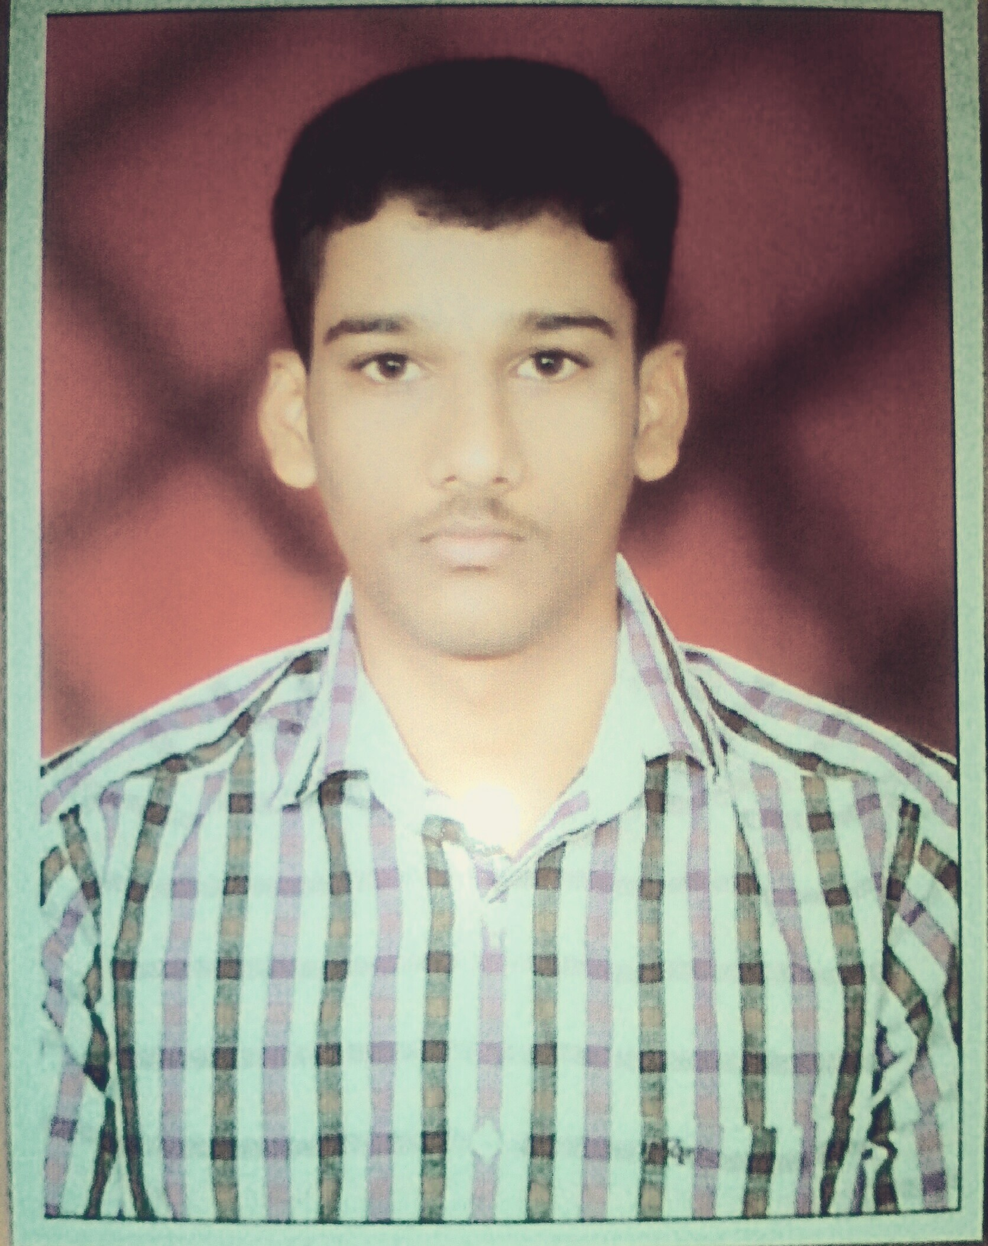

VIJAYAKUMAR, MBA.

VIJAYAKUMAR.371902@2freemail.com

CAREER OBJECTIVE

I want to excel in this field with hard work, perseverance and dedication.

BASIC ACADEMIC CREDENTIALS

Qualification | Institution | Board/University | Year Of passing | Percentage
M.B.A Logistics & Marketing | Park's College of Arts & Science,Tirupur | Bharathiar University | 2014-2016 | 73%
B.Com ( E.Com) | Park's College of Arts & Science,Tirupur | Bharathiar University | 2010-2014 | 60%
High School | P.V.K.N.Hr.Sec.School, Pongalur | State Board | 2010 | 60%
SSLC | P.V.K.N.Hr.Sec.School, Pongalur | State Board | 2008 | 50%

WORK EXPERIENCE

Company name : - TEX FLOOR

Destination : - HR Assistant and Administrator

Duration : - 01-June-2016 to 31-December-2016

Company name : - PARINITHA TEX

Destination : - Accounts Assistance

Duration : - 05-Jan-2017 to 30-June-2017

PROJECT EXPERIENCE

Company name : - DHL Logistics PVT LTD

Project title :- Logistics (Exporters and Importers preference in DHL Logistics )

Duration :- One year (03rd Mar 2015 - 07th Mar 2016)

IT PROFICIENCY

Microsoft Office, Internet Browsing, Normal Typing Speed.

ACHIEVEMENTS

National level seminar on “Current Issues in Teaching and Learning English”, park’s college, tirupur on 09th mar 2016.

National level seminar on “Social media and Marketing Presentation”, SNMV College of arts and science Institute of management, Coimbatore, on 09th Jan 2015.

4 (TN) Battalion NCC, National Cadet Corps Coimbatore, Passed in “B” Certificate on 27th Jul 2012.

INTERPERSONAL SKILL

Positive Attitude , Self-Confidence, planning & organizing.

PERSONAL DETAILS

Date Of Birth : 05-06-1993

Languages Know : English,Tamil,Telugu.

Marital Status : Single.

Nationality : Indian.

Area of Interest : Warehouse Management, Sales Executive, HR Management.

Hobbies : Music.

DECLARATION

I do hereby declare that the above information is true to the best of my knowledge.

