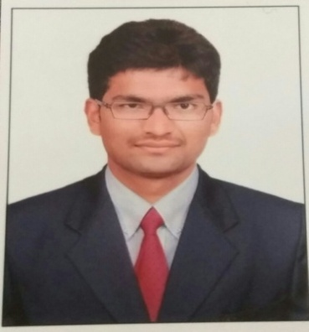
CURRICULUM VITAE
MAHESWARA
MAHESWARA.372265@2freemail.com

CAREER SUMMARY:
- Expert in covering all aspects from start up business, to financial management and company closures
- Proven ability in professional judgment dealing with the disclosure of information in financial reporting.
- Easy going nature and able to coordinate with all departments.

PROFESSIONAL QUALIFICATION:

COURSE | Institute /University | Year
CMA-FINAL | Institute of Cost Accountants of India | June 2016
CMA-INTER | Institute of Cost Accountants of India | Dec 2012
CMA – FOUNDATION | Institute of Cost Accountants of India | Dec 2011
CA-FINAL (II Group) | Institute of Chartered Accountants of India | May,2016
CA-FINAL (I Group -2 exemptions) | Institute of Chartered Accountants of India | May,2017
CA-IPCC | Institute of Chartered Accountants of India | Nov,2011
CA-CPT | Institute of Chartered Accountants of India | Dec,2010
B.COM(A&F) | IGNOU | JUNE 2014

Professional Experience:
  - Worked in GCMR & Associates for a period of two years from July 2015 to June 2017.
  - Completed three years of Articleship at M/s Venkaesh & Ram Chartered Accountants, Bangalore from March 2012 to March 2015.

Key works handled and performed are as follows

Accounting Procedures
    - Advising Clients Proprietary’s, Partnership Firms and Companies regarding design and implementation of Accounting Systems.
    - Assisting accounting personnel of the clients in application of Accounting Standards.
    - Preparation of Statement of Profit and Loss, Balance Sheets ,Cash Flow Statement provisional and projected financial statements.
    - Complying with the audit procedures and drawing conclusions based on audit evidence.

Statutory Audit
    - Compliance with requirement of schedule III of the Companies Act, 2013.
    - Compliance with Accounting Standards.
    - Drafting Audit Reports as per the new reporting requirements of Companies Audit Report Order, 2015 (CARO).
    - Concurrent and Revenue audit of Indian bank branch.
    - Statutory audit of Hotel industry.
    - Worked with Charitable Society audit in VARANASI

Internal Audit
- Verification of accounting procedures.
- Preparation of Bank Reconciliation Statement.
- Exposure in preparing special MIS reports and presented before board of directors and chairman.
- Lead, plan, and perform financial and operational audits.
- Checking of Account Payables, Account Receivables and Stock verification.

Taxation
    - Computation of Income Tax liability and filing of returns.
    - Preparation and Filing of TAX Audit Report.
    - Compliance with TDS Provisions and Quarterly Filings of E-TDS Return.
    - Filing of Service Tax and VAT Returns.
    - Preparation and Filing of VAT Audit Reports.
    - GST Migration and Registration

Registrations & Compliance Procedures
    - Company Incorporation, Firm Registration, VAT, Service Tax, Luxury Tax, Professional Tax etc.
    - Compliance with the statutory requirements as like ROC filings

Key Knowledge Areas:
    - Exposure in dealing works related to Scrutiny’s and Appeals
    - Exposure in preparing projected financial Statements.
    - Assisted in giving response to the Government.
    - Compliance with the Notices served to the clients in various matters.
    - Direct assistance to the client in VAT, Service Tax, Luxury Tax and Professional Tax related matters in compliance with the statutory requirements.
    - Knowledge on IFRS and Ind AS

COMPUTER PROFICIENCY:
    - Familiar with MS Excel, MS word, and SAP .
    - Working experience on Tally, VAT, Income Tax & TDS return filing Software’s.

Personal Qualities:
    - Excellent technical skills in Financial Accounting, Auditing, Compliance & Taxation.
    - Good communication (Written & Oral), interpersonal skills and a good team player
    - Ability to work as team leader as well as individually.
    - Self Motivated and Hardworking nature.
    - Adaptable to work environment.
    - Committed to work.

Personal Interest:
    - Playing Cricket, Playing Chess, Reading books and Travelling to new places.

