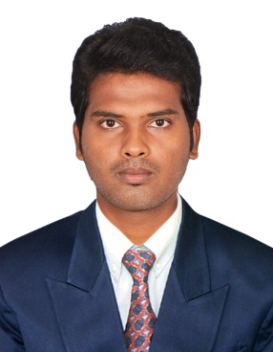
CURRICULAM VITAE

MAJEETH
MAJEETH.372296@2freemail.com

(Visit Visa Valid Until: 30th, October, 2017)

PROFESSIONAL OBJECTIVE

Provides extensive support covering all aspects of insurance claims, including direct contact to the appropriate third-party payers for all claims including denied claims. Manages all paid and unpaid claims, appeal claim's related inquiries

EXPERIENCE SUMMARY

Near 2 years of experience in the field of insurance claim processing operations.

PROFESSIONAL EXPERIENCE

Company : ONCOSPARK IND PVT LTD
Designation : Junior Analyst
Duration : March 2016 to July 2017.
Projects : United healthcare insurance, inland empire health plan
Kaiser.

RESPONSIBILITIES
- Review claim forms in detail to ensure that all provided information is complete and accurate.
- Reviewed electronic claims and processes data as required into the claims system, resolved computer generated correct conditions, and determined right payment.
- Review clients’ insurance policies to determine correctness and eligibility.
- Timely follow up on claim and appeal submissions..
- Processed claim forms, adjudicates for provision of deductibles, co-pays, co-insurance maximums and provider settlements.
- Performed audit of randomly selected claims to ensure quality processing.
- Reviewed and made sure that there is no omitted information.
- Obtain necessary documentation from various individuals and groups to provide credence to filed claims.
- Entered claims into computer utilizing knowledge of CPT, ICD-10 codes and medical terminology.
- Always be watchful any major rejections or denials – clearing carrier and ensure Follow-up on pending claims.
- Constantly keep track of both electronic and paper claims.
- Enter information in the company’s internal database for future or further reference.

EDUCATION QUALIFICATION

- Bachelor Degree - B.E ( Aeronautical Engineering )
Batch : 2011 - 2015
University : Anna University, Chennai.
OGPA : 6.5 out of 10

ACADEMIC PROJECT

- DESIGNING & ANALYSIS OF TURBINE BLADE COOLING

PERSONAL DETAILS

Date of Birth : 15/07/1993
Gender : Male
Marital Status : Single
Religion : Muslim
Nationality : Indian
Languages known : English & Tamil.

DECLARATION

I hereby declare that the particulars in the curriculum vitae are true and correct to the best of my knowledge and belief.

