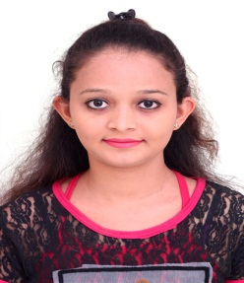

Name – JASMITA
JASMITA.372701@2freemail.com

CAREER OBJECTIVE
- To work hard with the full determination and dedication to achieve organizational as well as personal goals.
PROFILE SUMMARY
Worked with ITC Grand Central at Parel, Mumbai as a Pastry for 6 Months and
as Hostess.
Worked with Sugar and Spice at Doha, Qatar as a Pastry from 20/11/2015 To 09/07/2016.
Strength
- I am optimistic, confident & positive attitude personality and believe in smart work.
- Able to work as an group member or individual.

Academic Qualification
DEGREE | YEAR
S.S.C | 2010
H.S.C | 2012
HM .DIPLOMA | 2014
IT SKILL
Basic Computer Knowledge.
ARAE OF INTREST
- Pastry/ bakery / hostess department

PERSONAL DETAIL
Date of Birth : 3rd October, 1995
Marital Status : Married
Nationality : Indian
Languages Known : English, Hindi, Gujrati & Marathi
DECLARATION
- I solemnly declare that the above information is true and correct to the best of my knowledge. I understand that if any information given above is found false/incorrect, my candidature is liable to be rejected.

