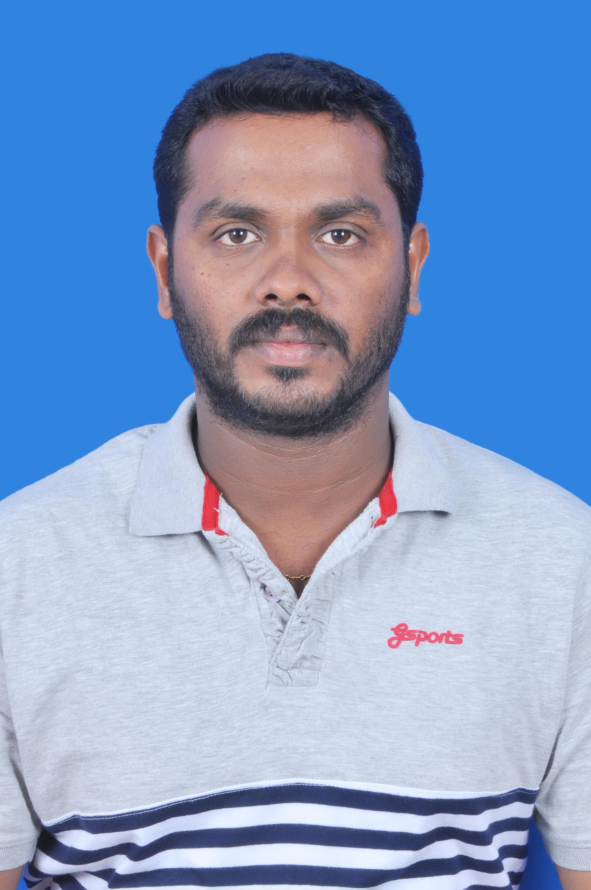
RESUME
Name : ANISH
ANISH.372740@2freemail.com
Date Of Birth : 08.03.1987
Sex : Male
Marital Status : married
Religion : Hindu
Nationality : India
Educational Qualification : 10th
Languages Known : Tamil, English, Malayalam & Hindi
Experience : Welder Murali Krishna
Engineering Works
Welder at sipcot, Ranipet
2007-2012
Experience : Welder Uma Industries
No, 106, Sidco Industrial Estate,
Sipcot, Ranipet-632403
8, Month Only Experience : Welder Builtech Engineering &
Contracting Co.W.L.L (QATAR)
2013-2017

Declaration
I hereby declare that all the information given above are true and correct to the best of my knowledge and belief.
Thanking you
Signature

