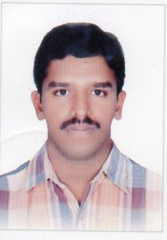
Applied for: - Electrical Forman
Personal Details:-
Full name : Koteswara
Koteswara.372880@2freemail.com
Date of birth : 05-05-1988
Education Details : ITI (Electrical)
Nationality : Indian
Languages known : English, Hindi & Telugu
Job Experience:-
I worked as an ELECTRICIAN as vijaya lakshmi electrical works at 01-06-2003 to 01-08-2007.
I worked as an ELECTRICIAN as Bauer Electromechanical company l.l.c in Dubai at 20-08-2007 to 28-02-2011.
I worked as an ELECTRICAL FORMAN as Aradous contracting& mep contracting w.l.l in Bahrain at 25-04-2013 to 25-04-2015.
I working as an ELECTRICAL FORMAN as Acme technical installations l.l.c in Adu Dhabi 11-09-2015-now
Work experience:-
I know DB dressing, communication, gladding, testing. Wiring as for the secdule, Communicated with workers, Fire cable work, emergency lighting work and co- ordinate with construction secdule with general contractors
Plz check my details. Given to job

