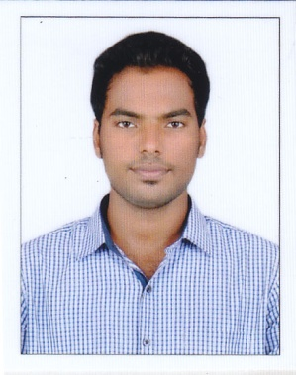
CANDIDATE PROFILE

PRABHAT
MAINTENANCE ENGINEER (MECHANICAL)

PRABHAT.372887@2freemail.com

PROFESSIONAL OBJECTIVE: | To be involved in a work where I can experience certainty and utilize my qualities such as leadership, interpersonal and technical skills for the better functioning and effective growth of the industry ,that to build a successful carrier
PROFESSIONAL QUALIFICATION: | - Bachelor of Technology in Mechanical Engineering from University of Calicut
SOFTWARE  SKILLS: | - MS office,C,AUTOCAD,SOLID WORKS
EXPERIENCES: | - Worked in GASHA STEEELS PVT LTD at Kanjikode as a Part time job in the post of Production and Quality engineer from 02/05/2014 to 11/05/2015  - Worked in WELLWORTH POLYMERS at Perumbavoor as Production and maintenance engineer from 14/05/2015 to 01/04/2017

EDUCATION PROFILE:
Course | Stream | University/Board | Institution | Year | % of Marks
B.TECH | MECHANICAL ENGINEERING | UNIVERSITY OF CALICUT | JAWAHARLAL COLLEGE OF ENGINEERING AND TECHNOLOGY | 2011-15 | 75.0
PLUS 2 | BIOLOGY SCIENCE | HSE KERALA | ASSISI E.M.H.S.S | 2009-11 | 86.4
SSLC |  | HSE KERALA | ASSISI E.M.H.S.S | 2009 | 90

CO-CURRICULAR ACTIVITIES:

- Completed project on FEASIBILITY TEST ON AUTOMATION USING ANALYTICAL HIERARCHY PROCESS
- Completed seminar on Z-PINCH FUSION BASED ON NUCLEAR PROPULSION
- Completed project on HYDRAULIC CENTER STAND WITH MOVING ARRANGEMENT
- Interzone participant in KABADDI 2014
- Member of school CRICKET team and FOOTBALL team from 2009-2011

LANGUAGES KNOWN:

Languages | English | Hindi | Malayalam | Tamil
Read | Yes | Yes | Yes | NO
Write | Yes | Yes | Yes | NO
Speak | Yes | Yes | Yes | Yes

DECLARATION:

I hereby declare that the above mentioned particulars are true to the best of my knowledge and I assure you that I will work in the right earnestness and fulfill the expectations of my superiors.

