CAREER OBJECTIVE
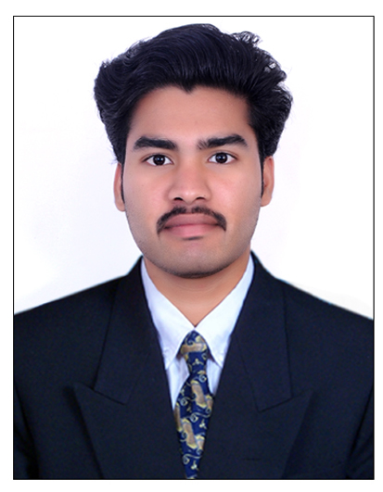

VIPIN KV
B-TECH in MECHANICAL ENGINEERING
Email: -
Vipin.373217@2freemail.com

LINGUISTIC SKILLS
- English
- Hindi
- Malayalam

To have a growth oriented and challenging career, where I can contribute my knowledge and skills to the organization and enhance my experience through continuous learning and teamwork.
EDUCATIONAL CREDENTIAL
B-TECH MECHANICAL ENGINEERING at KANNUR UNIVERSITY
VimalJyothi Engineering College, Chemperi with 67% aggregate
From July 2011to April 2015.

WORK EXPERIENCE
1) PRODUCTION ENGINEER
At Lokesh Machines Limited, MIDC Ranjangaon, Shirur(thaluk), Pune(Maharashtra).

From September2015 to September 2017.
Company Profile: - LML is an ISO 9001:2008 & TS 16949:2009 company certified by TUV NORD. The company is engaged in manufacturing and supply of precision automotive 6-cylinder, 4-cylinder, 3-cylinder, 2-cylinder engine blocks for Mahindra &Mahindra and Ashok Leyland Automotives.
Nature of Work
- Engine components inspection with focus on Connecting rod.
- Assist with plant activities.
- Provide support to operators in drawing Interpretation.

INPLANT TRAINING
- Attended training at KSRTC CALICUT, KERALA, INDIA on plant installation, material processing and preventive maintenance.
- Attended training on design and CNC programming for mold preparation in YASHODHA INDUSTRIES, L53-414111, MIDC AHAMMADNAGAR, (MAHARASHTRA), INDIA.
PROJECT DETAILS
- RE-DESIGN OF CRIMPING MACHINE:
Review: - A Crimping machine uses force and pressure to clamp or squeeze an object.
This project is done For PVN Industries, Kannur (Kerala)
PROJECT AIM: - To reduce the cost of production and improve stability of the system.
- DESIGN AND FABRICATION OF MILLING FIXTURE: -
Review: - Design and fabrication of milling fixture for CNC machine to make mementos.
TECHNICAL PROFICIENCY
SOFTWARE PROFICIENCY
- Auto Cad
- Solidworks
- Autodesk Inventor
- Gd&T

PERSONAL DETAILS
Name. : VIPIN KV
D.O.B : 02/05/1994
Mother : VIMALA
Blood Group :B+ve
- Best practice in designing mechanical equipment using AutoCad.
- Read and interpret Drawings and Specifications
- Have good problem solving capability.
- Strong team collaboration skills. Work closely with team members to achieve engineering goals

.

DECLARATION
I hereby declare that the above furnished details are true to the best of my knowledge and belief.

