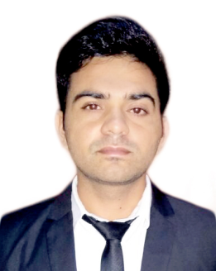
DEEPAK
BurJuman, Dubai, U A E
Languages Known: English, Hindi, Punjabi & Urdu
DEEPAK.373438@2FREEMAIL.COM

CARRIER OBJECTIVE:
A dynamic and hardworking individual with excellent communication, leadership and team skills seeking a role in Sales and Marketing industry to put my rich service experience to best use for the betterment of an esteemed organization
PROFESSIONAL PROFILE
- Acentria Solution (Du Telecom) Karama (Dubai) UAE.

Designation: Outdoor Sales Executive (August 2017 till now)
Role & Responsibilities:

- Focus on potential clients to bring new business by sales visits, phone calls, E-mails and cold calls.
- Propose and offer them unlimited free calls and not to pay for Smartphone and other international roaming benefits.
- Provide effective services and manage queries of clients.
- Ability to generate leads thorough current customer references, business consultants and friends.
- Continuous interaction with customers to make sure customer satisfaction and needs has been met.

- Vishal Udyog Pvt.Ltd.,Karnal( Haryana) India.

Designation: Sales Executive (June 2016 to July 2017)
Role & Responsibilities:

- Learn and utilize the company’s direct sales methodology to sell an exciting new product directly to commercial small and medium-scale farmer.
- Meet and exceed sales targets
- Advise farmers on the use of best practices in soil management and other Good Agriculture Practices
- Build a portfolio of long-term clients by conducting structured post purchase service visits with customers.
- Daily update sales and pipeline data using Google apps and the company’s proprietary Smartphone applications.
PERSONAL ACHIEVEMENTS:
- Certificate of appreciation (Agriculture implements) from Vishal Udyog in Q4 (2016).
- Certificate of appreciation (Agriculture implements) from Vishal Udyog in Q1 (2017).

TRAINING AND CERTIFICATION:
- Successfully completed Direct sales training certification from Vishal Udyog
- Successfully completed Product Training and passed product knowledge test in Du Telecom.

EDUCATIONAL QUALIFICATIONS:

Bachelor of Science [B.Sc](Hons) from Himgiri Zee University, (Dehradun) India.
- Higher Secondary Education from Brahmanand Public school, (Karnal) India.
- Expert in MS Office (MS Word, MS Excel, Power Point)

HOBBIES:
- Visiting new places & Interact with different type of peoples and learning about different cultures.
- Gym, Cricket and reading Novels

PERSONAL DETAILS:
- Nationality : Indian
- Visa Expiry (Visit): November 2017
- Occupation : Sales Representative
- Marital Status : Single
- Gender : Male

DECLARATION
I do hereby declare that all statements made above are true, complete and correct to the best of my knowledge and belief.
Place: Dubai Deepak

