ARUN MOHANAN

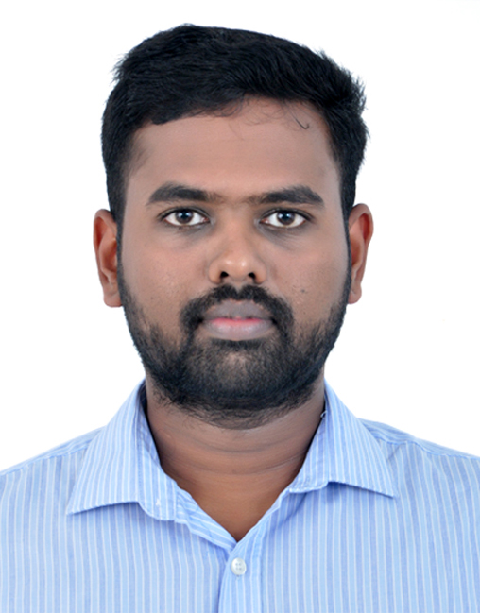

Arun
Arun.373619@2freemail.com

OBJECTIVE

To work in a dynamic and challenging job environment so that I wouldu be able to significantly contribute to the organization's requirements while continuously enhancing my skill-set

EDUCATION

Graduation
Completed B.tech in Information Technology at TKM Institiute Of
Technology Karuvelil Kollam (March 2011)

HSE
Completed 12th class - Science group Passed out in year – 2007 with 69
Percentage from TKM Higher Secondary School Karicode,Kollam

Schooling
Completed ICSE - Passed out in year – 2005 with 53 percentage
Infant Jesus Higher Secondary School Tangasseri Kollam

PERSONAL DETAILS

Date of birth : 15th December 1989
Gender : Male
Nationality : Indian
Marital status : Single
Languages Known : English , Malayalam, Hindi and Tamil

TECHNICAL SKILL SET

Operating Systems : Windows Server 2003 &2008R2
Windows 7&8 Vista,8.5 and10
Mac OSX. (10.5 and above)

- Certifications: Certified Cisco Certified Network Associate

- Certified Microsoft server administration (MCITP)

- Certified Server administrator (KELTRON Knowledge Services)

. Hired as a full-time systems administrator following initial consulting role. Provide Windows administration, network operating center (NOC) administration, LAN/WAN/VPN administration, VMware administration, and intrusion detection and prevention

· Diagnose hardware and software problems and replace defective components Load computer tapes and disks and install software and printer paper or forms.

· Maintain an inventory of parts for emergency repairs.

· Maintain logs related to network functions as well as list of required maintenance and repair records.
· Perform data backups and disaster recovery operations.

· Perform routine network startup and shutdown procedures and maintain control records.

· Installation of OS and required service packages: both open source and proprietary.

· Assist in the operation and maintenance of BT’s LAN/WAN and its services.

· ensuring that all IT equipment complies with industry standards.

· providing training and technical support for users with varying levels of IT knowledge and competence.

· Support users for Network related issues. Ensure that their connectivity requirements are addressed proactively.

· Assembling and troubleshooting computer.

· Resolving issues in Network cabling.

· Installing, maintaining and updating operating systems and software’s.

· Troubleshoot and resolution of technical IT Issues reported by users.

· Maintain network facilities in individual machines, such as drivers and settings of personal computers as well as printers.

· Apply OS patches and upgrades on a regular basis, and upgrade administrative tools and utilities. Configure / add new services as necessary.

· Perform ongoing performance tuning, hardware upgrades, and resource optimization as required. Configure CPU, memory, and disk partitions as required.

· Perform daily system monitoring, verifying the integrity and availability of all hardware, systems and key processes, reviewing system and application logs, and verifying completion of scheduled jobs such as backups.

· Perform regular file archival and purge as necessary.

· Troubleshooting a variety of computer issues.

· backup and granular restore support of Microsoft Exchange, Microsoft Outlook, Web Access (owa) and Microsoft Active Directory servers.

· Train users in use of software, hardware, and network systems.

· Design, configure and test computer hardware, networking software and operating system software.

· Special task/Projects assigned by IT In-charge as and when required.

· EPBX configurations support and maintenance of EPBX system including end phone device.

· CCTV Maintenance, Monitoring and backup.

· Supporting Branding & marketing team for managing technical issues in website.

· Assisting IT In-charge for Maintenance of intranet websites and EPBX Telephone (Speed dial & intercom Directory).

· Supporting HR Department for managing technical issues in Biometric attendance system.

· Hospital KIOSK Server/software maintenance and co-ordinate with Corporation IT Department and data center.

· Co-ordinate with maintenance department for resolving Network/Telephone cabling issues.

· Addressing all level 1 Technical issue’s (Networks, hardware’s, Software’s, Printers, Biometric and cctv etc from Kollam ESICE Branch.

Project implementation support/Technical support for other cs3 branches when requirement arise.

WORK EXPERIENCE

- Currently working at CS3 INFOMAT PVT. LTD. As I.T Engineer Since January 2013
- Cs3 entrusted me to carry out the works that are mentioned below for the following clients
- Travancore Cochin Chemicals (I.T Coordinator)
- Indian Navy (VMS Software)
- Indian School of Commerce
- MVJ Foods Melam

DECLARATION

I hereby declare that the above written particulars are true to the best of my knowledge and belief.

