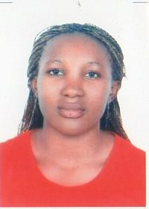

Name: Monique

Date of birth: 28/05/1989

Email: Monique.373768@2freemail.com

Nationality: Cameroonian

Visa Status: Tourist visa

City: Ajman, U.A.E

OBJECTIVE
Seeking a challenging position as a housekeeping

SUMMARY OF QUALIFICATIONS
- Ability to work in fast paced environments
- In depth knowledge of customers services
- Ability to create and maintain working relationship with others employees
- Resourceful team player and attentive at duty
- Excellent Communication Skills
- Always willing to learn and adapt very fast
- Self motivated and ability to excel with minimum supervision

WORK EXPERIENCE

- 2009-2012 : Worked general in SKY Hotel Cameroun
- 2012-2014 : Worked housekeeping in Hotel SAWA CAMEROUN
- 2013-2016 : Worked housekeeping house in dubai

ACADEMIC PROFILE
- 2009 : Bachelor Degree
- 2007 : GCE Advance Level Certificate
- 2005 : GCE Ordinary Level Certificate

DUTIES AND RESPONSABILITIES
- Administered vacuum and cleaning corridors, vending areas, guest services elevators, stairwells and landing adhering to preset standards and procedures.
- Performed cleaning windows and light fixtures in common areas, replacing bulbs as required.
- Refreshed housekeeping carts by providing clean linen and pull dirty linen and trash carts.
- Assisted in on-going projects such as rotating mattresses, deep cleaning rooms and shampoo projects.

- Ensured to report maintenance problems immediately.
- Maintained cleanliness of floor closets and vending areas, removal trash, wiped down shelves and counters.
- Monitored and controlled supplies and amenities, and minimize waste within all areas of housekeeping.

LANGUAGE PROFICENCY
- English : Good Level
- French : excellent level

HOBBIES
- Reading
- Playing
- jogging

