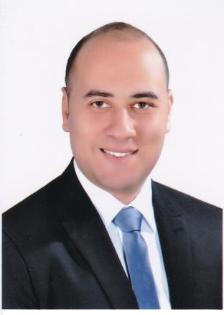

Emad
Emad.373930@2freemail.com

Career Objective

- To gain experience through a reputable institution and contribute to the success of this institution. I want to expand my skills for the benefit of my work and of my career.

Personal information

- Nationality : Egyptian.
- Date of birth : 19/1/1988.

- Gender : male.
- Military status : Exempted.

- Marital status : single.

Education and Courses:

- Bachelor of Commerce, accountancy Section, Kafr El-Sheikh University, 2009.
- ICDL course (Microsoft office, Windows, Word, Excel, Power Point, Internet and Access), 2009.
- English course under the auspices of Axon, 2009.

- Banking operation course under the auspices of The Central Bank of Egypt, 2010.

- Financial Manager Course from Egyptian Academy for the training of accountants, 2012.

- Better World Foundation (A Project of the AUC) “English course” 2012 - 2013.
- Oracle - Erp Financial R12 from Next Academic, 2015.

Work Experience:

1. EgyCross Assistancefrom 10/2013 till 09/2017.

Claims Handling Manager from 09/2015 till 09/2017.
- Responsibilities included:

  - Auditing the invoices and handling all financial claims.
  - Handling with all companies and all service providers.

  - Preparing and Auditing all payments and follow all outstanding balances for our customers “Insurance Companies”.

  - Follow-up all balances in banks.

  - Highlight profits and losses and present in customized reports on regular basis.
- Discuss financial issues with Accountants abroad.

Accountant from 12/2014 to 09/2015.
- Responsibilities included:
  - Making invoices and evaluate the medical procedure of the medical assistance
“Insurance Companies”.
- Customers and supplier’s payment follow up.
- Prepare daily reports for Suppliers and Customers.

As Travel Insurance Coordinator from 10/2013 till 12/2014.
- Responsibilities included:
- Receiving requests from the customers by Email, Fax or by Tel-Phone and recording the cases in the system.
- Send request to our suppliers.
- Handling the medical insurance cases till the insured get the assistance.
- Dealing and resolving with all problems of the insured's.
- Preparing monthly statistics regarding the work rate.

- El Assuity Telecom: from 7/2012 to 10/2013
- Responsibilities included:
- Customer account.
- Stocktaking and preparing daily & annual reports for Inventory.
- Prepare daily reports for sales and Customers account.

All the Accounting operations was handled by system “Double Click”.

3. Marina Travel: from 4/2010 to 7/2012
- Responsibilities included:
- Stocktaking.
- Analysis the Expenses in the American Journal.

Languages skills

- Arabic: mother tongue.
- English: Quite good (listening-speaking).

Computer skills

General
- Familiar with all Windows Operating Systems (Windows XP, Windows Vista, Windows 7 and 10).
- V.Good Knowledge in MS Office
(MS-Word, MS-Excel, MS-PowerPoint, MS-Outlook).
- Very Good Computer skills, application knowledge and search engines.

Accounting-related Computer skills
- Good in Accounting Using Peachtree
- Good in Accounting Using Double Click
- The basic of Oracle - Erp Financial R12.

Reference is available upon request

