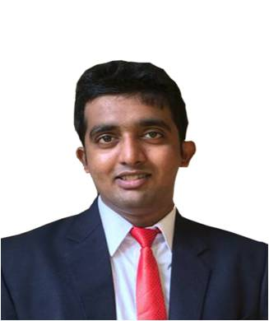
ARVIN

MEmail: Arvin.373948@2freemail.com

Objective

To achieve high carrier growth through a continuous learning process and keep myself dynamic, visionary and competitive with the changing scenario of the world

Educational Qualification
Course | Name of Institution | Board | Percentage | Year
MBA | Justice KS Hegde Institute of Management  Nitte | VTU | CGPA – 8.03 | 2017
BCOM | Sacred heart collage Madanthyar | Mangalore University | 64.6 | 2015
PUC | Vani PU college Belthangady | Higher Secondary | 74.9 | 2012
SSLC | St Theresa Eng Med High School Belthangady | State Board Karnataka | 60.6 | 2010

Professional proficiency

- DIFA (Diploma in Indian and foreign accounting) It includes Peachtree, QuickBook and Tally (correspondence)
- Microsoft Office
- Sony Vegas 13.0
- Windows Movie Maker
- Adobe Photoshop

Research

Title : A Study on Socio Economic Development of Rubber Growers of Neria
Belthangady Tq D.K
Year : 2014

Projects

Title : A Study on Socio Economic Development of Rubber Growers of Neria Belthangady.
Year : 2016

Title : An Industrial Project Study on Reliable Cashew Company Private Limited.
Year : 2016-17
Title : An MIA Project Study on Global Cashew Company Private Limited.
Year : 2016-17
Title : A Business Plan on Desire Cafe.
Year : 2016
Title : A Research Study on “Impact of Reliance Jio on Indian Telecom Industry”.
Year : 2017

Awards and Achievements

- Participated in six commerce fest and commerce quiz during under graduation (2012-2015).
- Won 2nd place in district level and 1st place in Taluk level (Dasara) ball badminton during under graduation (2014 and 2015).
- Won 3rd place in university level ball badminton (Mangalore University) during under graduation (2013).
- Won 2nd place in Short movie competition which was organized by Maestro Association, JKSHIM. Where I worked as an Editor and prepared Teaser, Trailer and edited movie named Umeed
(2015-2016).
- Participated and won many prizes in local shuttle badminton tournaments.
- Participation in various Sports & cultural activities at school & college level.

Languages Known
To communicate: English, Kannada, Hindi, Konkani and Tulu.
To write : English, Kannada and Hindi.

Area of Strength
- Hard and smart worker.
- Good convincing power.
- Ability to deal with people.
- Open to new learning and quick learner.
- Good at Technical work.
- Efficient Management and communication skills.
- Leadership skills.

PERSONAL DETAILS

Date of Birth : 13th December 1994
Religion : Roman Catholic
Nationality : Indian

Declaration

I hereby declare that the above-mentioned information is correct up to my knowledge and I bear the responsibility for the correctness of the above-mentioned particulars.

Yours faithfully

