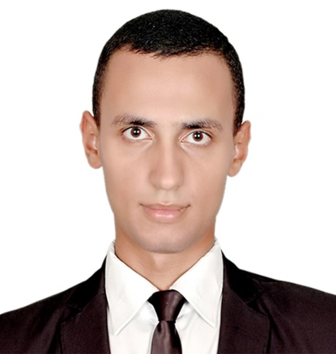
Mohamed
Mohamed.374107@2freemail.com

EDUCATION Graduate from Faculty of Law ,Cairo University
Academic Grade good
Language skills:
Arabic mother language
English very good (writing , listening )
Computer skills : Microsoft office , excel , word , ,E-mail , Google Drive , internet
Military status : complete the military service
CERTIFICATIONS:
1-ICDL Profile Certificate by the Cairo University For Foreign Languages With Grade : Excellent
2. contemporary Market course in business conversational english (Score: 100% out of 100%).
3. Customer service course by the Cairo University For Foreign Languages With Grade :Excellent
4-Human Development Certificate by the Cairo University For Foreign Languages With Grade : Excellent
5- Amadeus basic course with a degree granted :A
- 6- Certificate Of Experience by Youth For Tomorrow Model of Foreign affair
7-Certificate Of Honor by Utveeklingen For Ungdomar
8- Certificate of Recognition by the United Nations Information Centre (UNIC) And By SWEDISH INSTITUTE ALEXANDRIA
9- Certificate of Thanks and Appreciation by Leaders Prepare helwan Institute .
10- Certificate of Thanks and Appreciation by Leaders Prepare Cairo university
11- Certificate of Thanks and Appreciation by Resala Charity Organization
12 Certificate Of Experience by Cairo University Faculty of Economic and political science.
Experience:
1. training at Waled lawyer office for one month .

