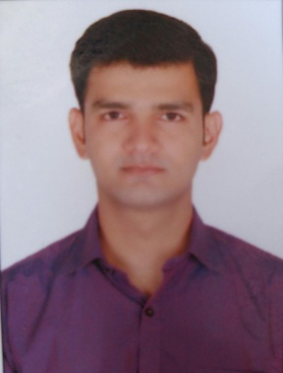  Career Snapshot  - HVAC Engineer for 3 years.  - Project Co-ordination for 2 years.  Technical Competencies:  - Extensive knowledge in HVAC, Chillers and VRF/VRF system products and solutions for ventilation needs.  - Strong proficiency in HVAC drawing interpretation.  - Executing project plans and program, ensuring that work is carried out in accordance with the company procedures and client satisfaction.  - Well versed in basic computer platforms like Word, Excel, Outlook etc.  - Ability to communicate professionally and effectively with all levels of staff  Education:  - PGDM (Operation Management) from Welingkar Institute of Management (2016)  - Bachelor of Engineering (Mechanical) from Mumbai University, India (2012)  Personal Details:  D.O.B: 27th August, 1990  Languages: English, Hindi, Gujarati |  | HVAC Engineer  Heat Load calculation Project co-ordination Team management Vendor Management Client support
 |  | Wadia Techno Engineering Service, India
September 2016–September 2017
Responsibilities:
- Heat load calculation, equipment selection of chillers and AHU, duct design and sizing.
- Preparing Design Basis Report, BOQ and project cost estimation.
- Coordinating with Vendor for shop drawing and approval of drawings.
- Meeting with client for their requirement, understanding their need and providing optimum solution.
- Worked on projects like Avgol, Tata Memorial Hospital project, Britannia factory in Gujarat and Pune, Karnataka Renewable Energy Development, SBI gift city Ahemdabad, Pavna Bungalow lonavala, BPCL Kochin.

Project Lead Engineer
Project co-ordination Team management

Keppel Offshore & Marine Engineering Service Pvt Ltd., India
April 2014 – June 2016
Responsibilities:
- Prepare machinery arrangement on rig using Auto CAD.
- Helped to prepare & review HVAC bid package, Equipment vendor certified drawings review.
- Duct sizing, Ducting layout & Equipment Layout.
- Liaise with senior management for progress data & reporting.
- Assigning work to team members and managing completion of work on scheduled period.
- Site support for resolution of Site Engineering Queries arising during job execution & Start-up assistance.
- As a Lead, Co-ordinate with counterpart and solve various site issue. Assign work to Asst. Lead Engineer and Draftsman’s. Timely issuance of drawing as per PPS. Planning and scheduling of project and drawings to issue, Findings of various issues on 3D model and solving. Work on 3D software to find interference and solve them.
- Projects worked on: PEMEX, PV DRILLING, UMW, HALUL, FECON & TRANS OCEANS.

Application Engineer
Project costing & Estimation Team management

Technolink Services, India
October 2013 – March 2014
Responsibilities:
- Costing and Estimation, Equipment selection of Air Handling Units, Technical offer preparation and Engineering analysis using proven and latest software.
Mechanical Engineer
Project Lead Team management

Increed Pvt Technology, India
October 2012 – September 2013
Responsibilities:
- Prepared contents for first year of Engineering and animated video lectures.
Achievements:
- Achieved target and awarded with ‘Performer of the Year’.
Site Supervisor
Team management

Supreme Engineering Services, India
July 2012 – October 2012
Responsibilities:
- Prepared B.O.M. as per drawings and supervision of the plant work shop.
- Assigning work to team members and get the work done on time.

