FARAZ
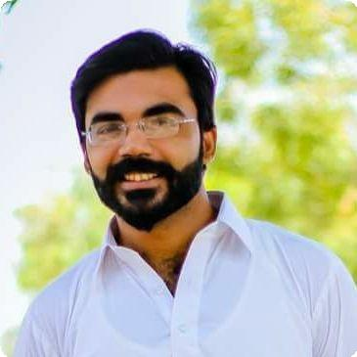
Civil Engineer, Philanthropist, Hard Worker, Cooperative,Flexibility, Adaptable to Change & Eager Learner.

Email: faraz.374148@2freemail.com
International City Dubai

EXPERIENCE

Trainee

AL JASR Private Limited

r 03/2017 - 08/2017 + Karachi

Worked on project Jhirk Mulla Katiar

On site experience gained.

Worked at their construction project.
ACHIEVEMENTS

- ACI NEDUET Fiber Reinforced Concrete(FRC) Bowling Ball Competetion

- Final Year Project in Structural Engineering completed with flying colours.

Intern

National Engineering Services Pakistan(NESPAK)

r 06/2015 - 08/2015 + Karachi

Engineering and construction organisation(government Sector)

Worked at Cresent Bay Development, DHA phaseVIII. On site experience gained.

Intern

G3 Engineering Consultants

r 06/2014 - 08/2014 + Karachi

Company Description

Worked at Flood Emergency Reconstruction. On site experience gained.

Worked at their construction project.

EDUCATION

B.E Civil Engineering

NED University of Engineering & Technology

r 2012 - 2016 + Karachi,Pakistan

- Highly proficient in using software like MS Office and other computer related softwares.

PROJECTS

FYP (Structural Analysis)

r 2016 + NEDUET

A Research and Analysis based project of Durability of slag concrete in marine environment.

Residential House Design

r 2015 + Karachi,Pakistan
Designed a 120 square yard residential house

Spaghetti Truss Bridge

r 2015 + NEDUET

Designed and tested a spaghetti truss bridge as a class project.

Intermediate

Govt. Dehli College

r 2010 - 2012 + Karachi,Pakistan

LANGUAGES

Matriculation
English
Proficient
Whitehouse Grammar School Karachi | Urdu | Powered by /
r 2001 - 2010 + Karachi,Pakistan
 | Native
www.enhancv.com

