**CURRICULUM VITAE**

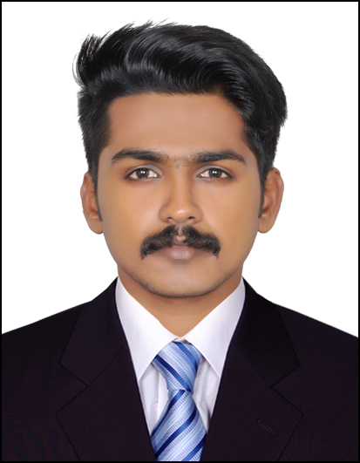

**SAJEEV**

**DUBAI, U.A.E**

**E-mail :** [**sajeev.374201@2freemail.com**](mailto:sajeev.374201@2freemail.com)

**Career Objective**

To be associated with a progressive organization which can provide me with a dynamic work sphere to extract my inherent skills as a professional, use and develop my aptitude to further the organization’s objectives and also attain my career targets in the progress.

**Professional Skills**

* Able to understand and energize others.
* Ability to negotiate at all decision-making levels.
* Resolute relationship building skills.
* Can think, talk and act commercially.
* Formulating recommendations and solutions.
* Having the required confidence, drive and enthusiasm.
* Comfortable with working on a new set of challenges and a completely different industries and sectors.
* Excellent analytical, problem-solving and communication skills.
* Highly motivated individual with abilities to prioritize work and to meet deadlines.
* Experience in motivating and fostering team environment.
* Maintain positive attitude in the face of changes in work assignments.
* Punctuality time management capability.
* Can work efficiently in a group as well as an individual.
* Self-motivated, hardworking and goal-oriented with a high degree of flexibility, creativity and commitment.

**Educational Attainments**

|  |  |
| --- | --- |
| * **MBA Shipping &Logistics and Marketing (August 2015-May2017) Bharathiar University** * **B.com Cooperationv (April 2015)**   **Kannur University** |  |

**Professional Qualification **

**DECLARATION**

* **Manual & Computerized Accounting -August 2017**

**Sree Sankaracharya Computer Center**

* Tally erp9

**Work experience**

* **Warehouse Assistant at Dtdc Courier and Cargo International,Coimbatore**

(Part-time job) (4/2016 to 3/2017)

**Duties u**

* Facilitate the shipping of products from one destination to another
* Arrange transportation, schedule staff, and orchestrate deliveries to meet customer demand with little to no delay
* Receives products and coordinates delivery
* Prepares loads for shipment
* Takes steps to avoid quality control issues
* Makes sure warehouse capacity is kept at optimal levels
* Manages activities throughout the order fulfillment and transportation cycle to make sure established deadlines are met
* Oversees inventory of goods and vehicles
* Streamlines shipping and transportation process

**Acadamic Projects**

At Post Graduation Level**:**

* A Study on **Service Quality in Logistics Management** with Special References to Atlantica Shipping and Logistics Pvt.Ltd, Cochin for 2 months ( May-2016 to June-2016)

At Graduation Level**:**

* A Study on **Financial Performance** of Al Man Hal Enterprises Pvt.Ltd, Kasaragod (Feb-2015 to March-2015)

**Computer knowledge**

* **Tally**
* **MS Office**
* **Photoshop7**
* **E-commerce**
* **Web and Social skills**

**Area of Expertise**

* Efficiency in Technical Analysis
* Efficiency in calculations
* Grasping new technical concept and utilizing them
* Efficiency in Inventory control

**Personal Information**

* Date of Birth : 22nd /February 1994
* Nationality : Indian
* Marital Status : Single
* Languages : English, Malayalam,Tamail
* Visa status : Visit Visa.

**Declaration**

I hereby declare that the above-mentioned information is correct and very much sincere as knowledge.

Place: Dubai **Sajeev**