FEMIN
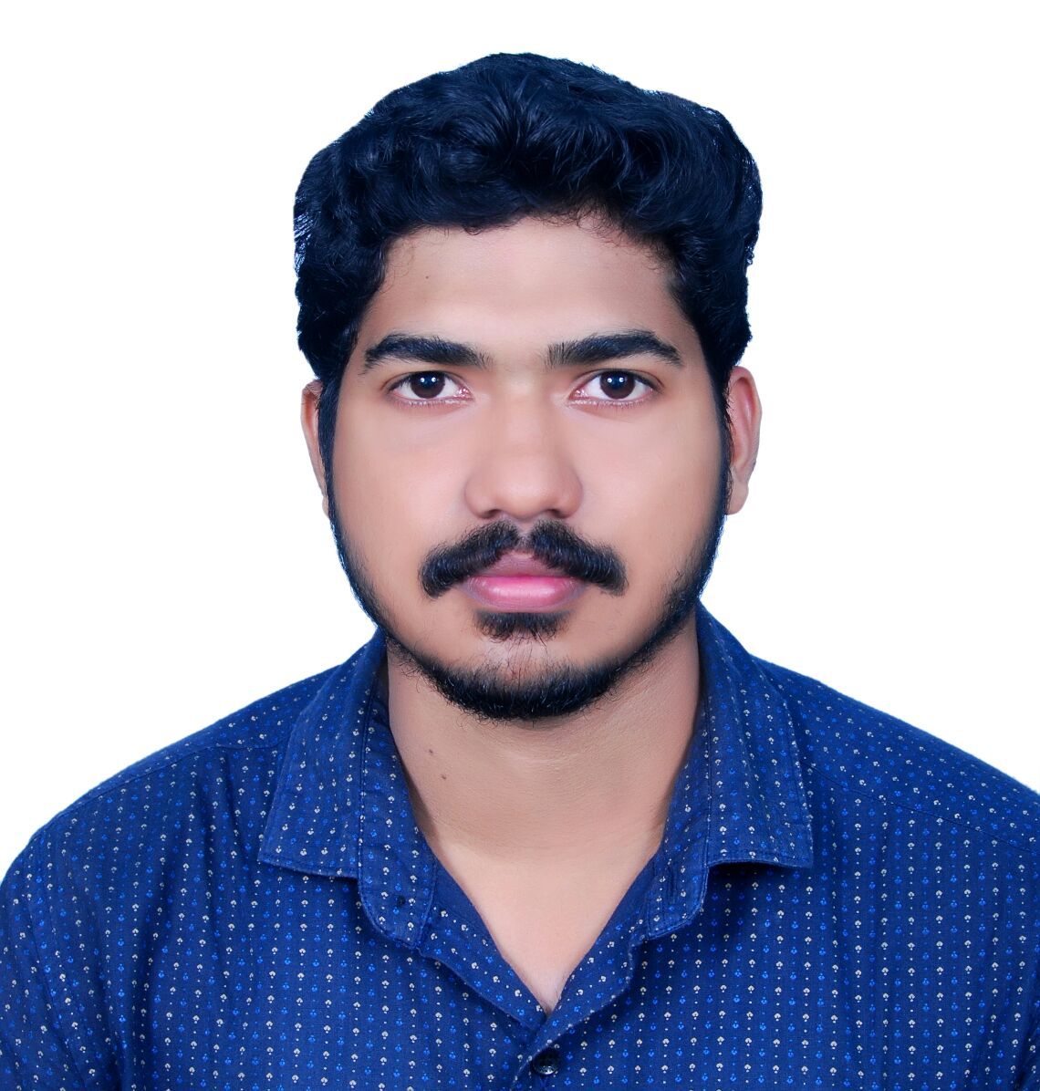
Email: femin.374364@2freemail.com

Career Objective
To work in a stimulating environment where I can apply and enhance my knowledge, skill to
Serve the firm to the best of my efforts.
Professional Summary
Qualified Safety professional with a talent for Training and staff instruction. NEBOSH, IOSH certificate holder and graduate in Electrical engineering. Well Trained to identify probable risks, preventing accidents and implementing safety regulations. Provides detailed information and reports, with relevant required preventive and corrective measures to ensure health, safety, environment, and security requirements are implemented by appropriate personnel and contractors in all major project work areas. Convincing, strong communicator, excellent report writing skills.
Work History
Safety Supervisor (07/2016 to 10/2017)
STEEL WORLD ENGINEERING & CONSTRUCTIONS PVT.LTD – ERNAKULAM, KERALA
- Develop and ensure the implementation of the HSE Management System in compliance with the international standards (ISO 14001 / OSHA18001, others)
- Conduct safety inspection, training and audit compliance with HSE procedures and enforcing safety guidelines according to federal regulations and standards.
- Encouraging a culture of safety and Conduct risk assessment for different activities.
- Promote environmental and safety awareness among the workforce and hold regular meetings with supervisors, workers, sub-contractors, Staff and manage the Field HSE team.
- Establish and lead HSE Meetings /Conference between the company and Contractors/service companies as required.
- Ensure that all sites activities carried out by the company are conducted in strict accordance with corporate HSE Standards and project requirement standards.
- Lead and provide assistance in completing Task Risk Assessments and Job Safety Analyses for projects. Conduct safety reviews and audits on project installation activities.
- Developing and implementing safety policies for preventing workplace injuries.
- Ensuring workers are wearing safety gears and taking actions against violators of the rules.
- Provide support and direction for all employees on HSE related issues.
- Key personnel of Emergency Rescue Team.
- Coordinate projects, planning, scheduling and budgeting.
- Conducting investigation on workplace accidents, if any, and taking appropriate actions.

Education
- Bachelor of Technology: Electrical and Electronics Engineering (2016)
Albertian Institute of Science & Technology - Kochi, KL, India
- Higher Secondary: SCIENCE (2012)
Higher Secondary School of Jesus - Kochi, KL, India

Certifications
- NEBOSH (International General Certificate)
- IOSH – Managing Safety
- MEDIC FIRST AID
- DIPLOMA IN ELECTRICAL CADD
Skills
Soft skills
- Identifying Hidden Hazards
- Visual Hazard Communication
- Convincing Presentations
- A fast learner & good listener
- A Good Communicator
- Excellent Attention To Detail
- Ability to work under pressure

Technical Skills
- Proficient in Microsoft Office Tools like Word, Excel, PowerPoint
- Proficient in AutoCAD, Electrical Cadd
- Computer Programming language C
- Computer operating systems windows 7, 8, 8.1,10.

Personal Profile
Gender : Male
Date of Birth : 24th November 1994
Marital Status : Single
Nationality : Indian
Language proficiency : English, Hindi & Malayalam
Driving License : Indian 2 & 4 Wheeler.
Visa Status : Visiting visa

Declaration
I hereby declare that the above information is true and correct to the best of my knowledge.
Yours Sincerely,

