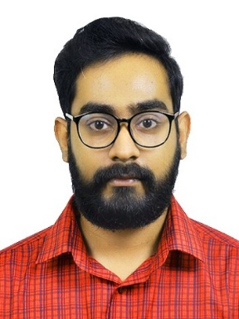  RAHUL  MECHANICAL ENGINEER  Email :  RAHUL.374394@2freemail.com  UNITED ARAB EMIRATES  Visa Status : Tourist visa valid till 3rd December  Personal Data  Nationality Indian  Sex Male  Marital Status Single  Hobbies Listening to music Watching Movies  Home town Trivandrum, Kerala  Languages Known:  English , Malayalam , Hindi | Career Objective  Seeking a career that allows me to grow professionally, while being able to utilize my skills for the betterment of the organization with the best use of my dedication, determination and resourcefulness.  Education  M.Tech in Machine Design (2017) from Sree Chitra Thirunal College of Engineering affiliated to A.P.J Abdul Kalam Technological University passed with an aggregate of 7.9 GPA  B.Tech in Mechanical Engineering (2014) from Muslim Association College of Engineering Venjaramoodu affiliated to Kerala University passed with an aggregate of 7.05 GPA  12th KERALA (2010) from Sarvodaya Vidyalaya, Trivandrum passed with an aggregate of 73.4%  10th KERALA (2008) from Sarvodaya Vidyalaya, Trivandrum  passed with an aggregate of 86%  Additional Qualification  - MEP course in HVAC Design and draughting.  - AutoCad MEP  Technical skills  - Manufacturing and material science: Casting, Severe plastic deformation, heat treatment  - Mechanical Testings  - Software tools : Abaqus, AutoCAD, Think3, HAP, Pro E  - Operating system : Windows 10 ,Windows xp, Windows 7, Linux  - Others : M S –office  - Good knowledge on mechanical subjects
Projects  Title: Study of Equal Channel Angular Pressing on Mg alloys  Duration: 6 Months | Project Details  Description: The main objective of the project was to increase the strength and hardness of magnesium alloys by a SPD process known as ECAP. The project was done at NIIST-CSIR
Title: Acoustic source characteristics of an IC Engine  Duration: 3 Months | Description: The aim of the project is to investigate the medium speed IC-engine acoustic source characteristics by using a Sound Level Meter.
Other projects  Group members :3  Duration : 6 Months | Description: Modelling and simulation of MR Damper
Strengths
- Self-learning
- Hard working
- Organizing Skills
- Goal Oriented
- Good leadership qualities

Declaration: I hereby declare that the above mentioned information is correct up to my knowledge and I bear the responsibility for the correctness of above mentioned particulars.

Place: Abu Dhabi
Date:

