CURRICULUM VITAE
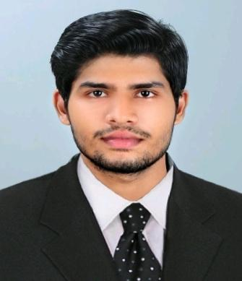

FAIZAL
Faizal.374557@2freemail.com

O B J E C T I V E | Seeking a career that is challenging and interesting which
 | gives me an opportunity to learn and enhance my skills and
 | strength in conjunction with organization goals and
 | objectives.

P R O F E S S I O N A L E X P E R I E N C E

Warehouse Supervisor with Whirpool India Ltd,

Kerala, India - May to October, 2017

Responsibilities

- Supervision, Inspection, Coordination with charge heads.
- Labour Management.
- Preparation of work Schedules and the execution of the same.

- Inspection of warehouse in accordance with the provided despatch quantity.

- Assurance of Quality and Quantity at work site.
- Ensuring that all materials used and work performed are as per orders.

- Day-to-day management of the warehouse, including supervising and monitoring labor force.

- Preparing site reports as required.
- Resolving any unexpected technical difficulties and other problems that may arise.

P R O F E S S I O N A L S K I L L S

E D U C A T I O N

P E R S O N A L

D E T A I L S

D E C L A R A T I O N

o Good inter personal skills and ability to convince people and a good motivator.
o Ability to grasp new things and information.

- Ability to work in a team and confident in taking responsibilities as and when needed.

o Able to work within a team. o Able to work under pressure.

- Software Skill SAP
Microsoft Excel, Word

  - B. Com, M.G University, India (2014-2017)

  - Diploma in Logistics and Supply Chain Management, CII, Vidya Bharathi Group of Institutions, Kalamassery, Cochin, India (2016-2017)

  - Diploma in IAAP, Vidya Bharathi Group of Institutions, Kalamassery, Cochin, India (2017)

  - 12th Grade, Crescent Public School, Aluva, Kerala, India (CBSE-2012)

  - 10th Grade: Crescent Public School, Aluva, Kerala, India (CBSE-2010)

DOB : 24-01-1994

Nationality : India
Marital status : Single
Languages known : Malyalam, English, Tamil, Hindi

I hereby declare that the above stated particulars are true to the best of my knowledge and belief and if given a chance to serve your organization I will do my best for the progress.

P L AC E: D U B A I

