NIVAS UAE Visit Visa Valid Upto:28Feb2018
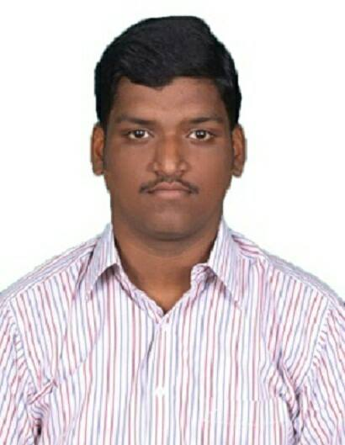

E-mail: nivas.374868@2freemail.com

CURRICULUM VITAE OF MECHANICAL ENGINEER
Objective :
To work in a challenging environment and build an outstanding career thereby making an irreplaceable contribution to the company by the way of accelerated progress towards respective goals. To achieve excellence by working with highest professional standards.

Profile :
Completed Bachelor of Mechanical Engineering graduation from Infant Jesus College of Engineering And Technology, 2011 - 2014.

Completed Diploma In Mechanical Engineering from Arasan Ganesan Polytechnic College, 2008 – 2011.

Work Experience:
Worked as Mechanical Maintenance Engineer In Ind-Barath Power Gencom Limited 3x63 MW Coal Based Thermal Power Plant Under Operational Energy Group India Private Limited, Thoothukudi Tamilnadu, India.

01st July 2016 to 14 Nov 2017 Maintenance Engineer-Mechanical.
01st July 2015 to 01July 2016 Assistant Engineer-Mechanical.
01st July 2014 to 01July 2015 Graduate Engineer Trainee (GET-Mechanical)

Role & Responsibilities :
- Preparing work permits and monitoring the work.
- Preparing maintenance check lists. Along with equipment study and history card.
- Preparing preventive maintenance schedules for equipments and executing them.
- Coordinating with maintenance team to complete the job in time.
- Maintenance and servicing of any high pressure as well as low pressure pumps
- Using Vibration meter for studying and analysis of Vibration Behaviors of Equipments.
- Fire hydrant line fixing fire hydrant pump maintenance and servicing work.
- Done annual inspection of Boiler and Turbine auxiliaries, such as Induced Draught fan, Primary Air fan, Secondary Air fan, Low Pressure Heater drain pump, Boiler Feed Pump, Cooling tower, etc,.
- Maintenance of Belt Conveyors, conveying rollers, crushers, screens, gearboxes and Dust extraction system of Coal handling plant and compressors.
- Checking hydro test and rectifying it based on situations.
- Planed & Scheduled jobs, Un planed day by day minor defects & running defects, PM as per task at various frequency, Monitoring & follow-up vibration, temperature, noise & lubrication schedules as per daily, weekly monthly & yearly.
- Ensure high availability of the boiler, turbine auxiliaries, rotating equipments.
- Minimise cost of maintenance and optimise equipment life cycle cost.

Planning and schedule preparation for annual overhauling and short time shutdown.
- Plan resource requirements for maintenance – manpower, materials and contracts.
- Prefabrication and erection of circulating water system pipes.

Manpower, Tools & tackles, Machines and consumables planning.

Allocation of manpower as per schedule requirement.

Academic Qualification:
- Bachelor of Mechanical Engineering (BE) 2014 :

College : Infant Jesus College Of Engineering& Technology, Thoothukudi.
University : Anna University, Tamilnadu

Percentage secured in BE …………………………..70%

- Diploma In Mechanical Engineering (DME) 2011:

College : Arasan Ganesan Polytechnic College, Sivakasi
University : Directorate of Technical Education, Tamil Nadu.

Percentage secured in DME ………………………….72%

III. Matriculation Education (SSLC) 2008:
SSLC from Kamak Matriculation Hr. Sec. School Thoothukudi with 65% aggregate.

Training undergone:
Organization : Thiyagarajan Motor Works Private Ltd
Duration : 21.10..2009 -31.10.2009

Organization : Southern Petrochemical Industries Corporation Ltd
Duration : 26.04.2010 -07.05.2010

Academic Projects:
Main Project (DIPLOMA) | Speed Control Of Vehicle Using Fuel System
Mini Project (BE) | Pollution Control In Two Stroke Engine Using EGR Valve
Main project (BE) | Multidirectional Unloading Tipper

Papers Presented:
- Foundry
- Rapid prototyping

Area Of Interest:
- Power Plants
- Petroleum Industries
- Oil and gas Plants
- Automobiles Industries
- Air force and Maintenance

Personal Details:
Name | Nivas.
Date of Birth | 28th October 1992
 |  | Languages known | English, Tamil & Hindi
Sex | Male | Nationality | Indian
 |  | Marital Status | Single

Personal Strengths:
Positive Attitude, Dedicated and Hardworking, Easily adapted in Team Work,
Inter Personal Skills, Organizational skills, Proficient Communication Skills

I hereby declare that the above-furnished knowledge is true to the best of my knowledge and belief.

Date: (Nivas)

