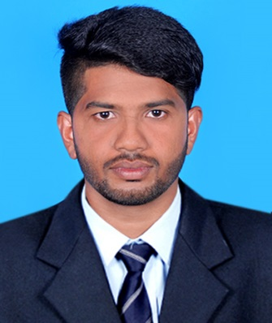
AKHIL
Piping Engineer with 3½ years experience
Email: akhil.375012@2freemail.com
Current Location: UAE
Visa Type: Visit

EXECUTIVE SUMMARY

Worked in the core area of piping for 3½ years in Oil & Gas sector. Expertise in handling petrochemical projects in related to Engineering Fabrication and Construction. Consistently adhere ASTM standards and codes (ASME B31.3).
EXPERIENCE: Above 3 years of experience in Oil & Gas Piping field.
10/08/2015 – 11/11/2017 SITE ENGINEER
C.P.S Engineering & Contractors, Cochin
Project: DHDS Offsite, Bharat Petroleum Corporation Ltd.
Cochin, Kerala, India

08/06/2015 – 25/07/2015 SITE ENGINEER
C.P.S Engineering & Contractors, Cochin
Project: Shutdown Piping, Bharat Petroleum Corporation Ltd.
Cochin, Kerala, India

02/06/2014 – 30/05/2015 SITE ENGINEER
Nimbus Engineering & Contractors, Cochin
Project: IREP, Bharat Petroleum Corporation Ltd.
Cochin, Kerala, India

AREA OF EXPERTISE

- Handle tasks of providing design and construction drawings under the instructions of senior pipeline engineer.
- Expertise in work method of statement, P&ID, pipe plan, pipe support and structural drawings.
- Responsible for performing tasks within piping codes and standards, piping specifications and regulations.
- Familiar with design reviews, subcontracting and pipeline installations including Fire Water Lines.
- Possess sound knowledge of pipeline codes and regulations
- Ability to work with minimum supervision and handle multiple tasks
- Good background in fabrication, construction, testing, monitoring and punch list clearing
- Inspection, execution and evaluation of various mechanical components

QUALIFICATIONS

- Degree of bachelor of engineering in Mechanical Engineering from PSN Institute of Technology and Science, Tirunelveli (2010 to 2014)
- Plus Two from GBHSS, Perumbavoor (2008 to 2010)
- SSLC from SMHSK, Kombanad (2008)

STRENGTHS

- Expertise in Site Supervision & Coordination
- Good working relation with clients and sub-contractors
- Passionate in sorting technical activities.
- Confident to assume work challenges.
- Fast learner.

ADDITIONAL QUALIFICATIONS

- Undergone training in Soft Skills conducted by HP Education India at PSN Institute of Technology and Science, Tirunelveli
- Successfully completed Pro/Engineer Wildfire – Modeling
- Computer knowledge: MS Office

PERSONAL PROFILE

Date of birth : 08/01/1992
Nationality : India
Sex : Male
Marital status : Single

PASSPORT DETAILS

Place of Issue : COCHIN
Date of Expiry : 17/11/2026

LANGUAGE PROFICIENCY

English : Verbal & written
Hindi : Verbal & written
Malayalam : Verbal & written
DECLARATION
I hereby declare that all the information given above is true to the best of my knowledge and belief.
Date:
Place: Akhil

