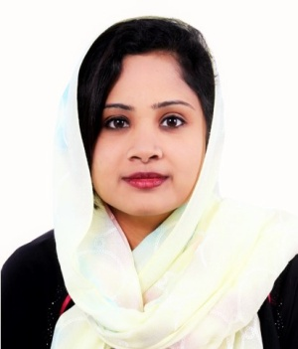
CURRICULUM VITAE
DINSATH
Email ID : dinsath.375097@2freemail.com

CAREER OBJECTIVE
Looking forward for an organization that offers a challenging, stimulating, learning environment to work in and provide scope for individual & organizations development, which offers attractive prospects for long term development and career growth.
EDUCATION QUALIFICATION
- DIPLOMA IN AIRPOT AND AIRLINE MANAGEMENT TRAINING
- HSC
- SSLC
WORK EXPERIENCE
Working as Cashier in Carrefour (CCO) Majid Al Futtaim Dubai, From February 2017 - Till date.
Roles & Responsibilities:
- Scanned groceries and ensured proper price scanning. Balanced daily cash register receipts and provided quality customer service.
- Answered customers' questions, and provided information on procedures.
- Counted money in cash drawers at the beginning of shifts to ensure that amounts were correct and that there was adequate change.
- Offered customers carry-out service at the completion of transactions.
Worked as Document Controller Cum Receptionist in EAGLE EYE CONSULTANTS Private LTD India, From August 2015 - September 2016.
Roles & Responsibilities:
- Maintains specifically assigned project database/s.
- Coordinate all activities related to the document control procedures, including technical documents.
- Ensures proper document classification, sorting, filing and proper archiving.
- Performs file backup to ensure proper storage and archiving of electronic registers.
- Welcomes visitors by greeting them, in person or on the telephone; answering or referring inquiries.
- Directs visitors by maintaining employee and department directories; giving instructions.
- Maintains security by following procedures; monitoring logbook; issuing visitor badges.
- Maintains telecommunication system by following manufacturer's instructions for house phone and console operation.
TECHNICAL SKILL
- MS Office (MS Access, Excel, Word, PowerPoint) MS Outlook - Email and Internet.
ACCOMPLISHMENT
- Quick learner
- Self-confidence and positive attitude.
- Good communication skills.
LANGUAGES KNOWN
- English
- Hindi
- Tamil
PERSONAL PROFILE
- Date of birth : 12/08/1990
- Gender : Female
- Marital status : Single
- Nationality : Indian
- Visa status : Employment Visa
DECLARATION
I do hereby declare that the above particulars are true to the best of my knowledge.
Date :
Place : DINSATH

