CURRICULUM VITAE
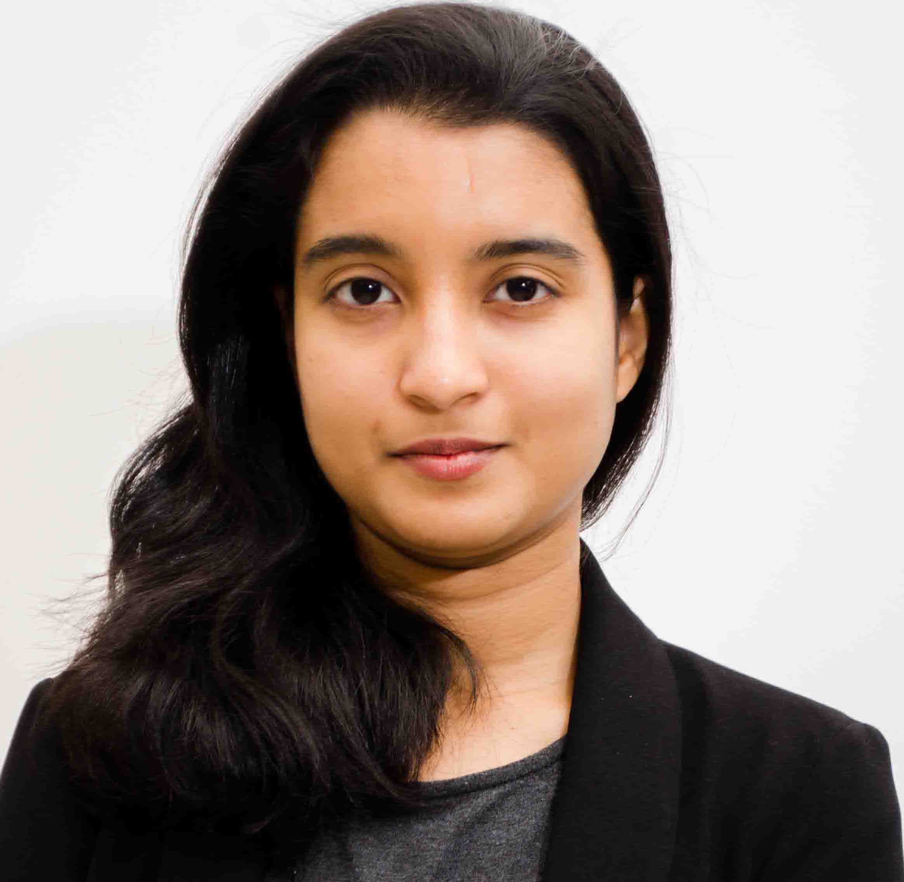
THASNEEM
Email : thasneem.375365@2freemail.com

Profile
Over 2.9 years’ experience in various accounting role. Sound Knowledge of overall finance functions. Having very good analytical, organization and communication skills. Highly efficient to acquire and maintain relationships within and other team members. Strong customer relationship management skills.
Core Competencies
Excellent knowledge in computer operations and softwares like SAP, OPERA, HITS, ADACO, MS OFFICE etc.
Career History

Associated with Aloft Abu Dhabi, owned by Abu Dhabi National Exhibitions Company and Operated by Marriott International Inc. since September 18, 2014 until June 18, 2017.
Achievements:
- First promotion in 8 months from the date of joining
- Awarded as Talent of the Month (August 2015)
- Awarded Certificate of Appreciation for the 2015 exceptional ADIPEC Event
- Relieved credit manager for 2 months.
Highlights:
- Cross trained to Accounts Payable functions
- Was undergoing training for Balance Sheet reconciliation
Latest position: Accounts Receivable Supervisor
Start Date: June 1st, 2015
End Date: June 18th, 2017

Key Responsibilities
- Ensure group billing and invoices are prepared correctly and efficiently
- Effect timely collection of all outstanding debts and past due accounts
- Prepare month end receivable reports, statements and reconciliations
- Monitor AR aging reports and create provisions for doubtful debts over 180 days
- Schedule monthly credit meetings and prepare business meeting minutes
- Ensure advance deposits are properly recorded, prepare reminders and follow ups to the client for delayed payments
- Investigate & resolve all billing & account discrepancies.
- Prepare quarterly exception reports and circulate to the regional office for approval
- Credit card reconciliation, handling credit card queries and charge backs
- Monitor daily credit management operations are in compliance with the credit policies and standards
- Ensure credit applications for all new accounts are completed and approved
- Review paymasters and high balance reports to ensure proper actions have been taken
- Prepare employee city ledger deductions for the Payroll process
- Prepare JV for month end AP/AR clearance accounts
Previous Position: Finance Coordinator (Category: Supervisor)
Start Date: September 18, 2014
End Date: May 30, 2015
Domain Experience
- To monitor and track banking transactions on a daily basis and prepare bank reconciliations on a monthly basis
- To prepare and handle contract documentation including approvals and maintaining a comprehensive tracking sheet in order to ensure timely renewal of the contracts
- To assist Director of Finance in budget and capital expenditure administration which includes preparation and tracking of project release documentation and approvals
- Testing and implementation of easy track system for managing, tracking & tagging fixed assets, furnitures, fixtures and equipment’s as a part of owner’s project
- To assist DOF in completing CSA, QCC and other reporting deadlines as per schedules
- Payroll administration of the department including time and attendance and leave requests
- To handle purchase and store requisitions of department supplies
- Relieving finance talents during vacation
Academia

- Pursuing for Association of Chartered Certified Accountants (2017)
- Bachelors in Business Management (specialized in Finance) with 77% aggregate in 2013 from M.S. Ramaiah Institute of Management, Bangalore University, Karnataka. Project
Description: Working Capital Management
Role: Analysis
Company: Brook & Ripples Swimming Pool Equipment Trading LLC
(Bin Moosa Group)
Location: Abu Dhabi, UAE
Period: January 2013

- Higher Secondary Education: Presentation Higher Secondary School, Kerala board with 78% aggregate in 2010.
- Secondary Education: M.I.C English Medium School, CBSE Board, Kerala with 83% aggregate in 2008.
Accomplishments
• Received Academic Excellence Award in the year 2011 and 2012.

Personal Strengths
- Quick learner
- Well organised and hard working
- Flexible with work timing.
- Innovative and systematic
- Effective time management

Personal Vitae

Marital Status : Married
Sex : Female
Date of Birth / Age : 01-07-1992 / 25
Nationality : Indian
Known Languages : English, Malayalam, Hindi (basic)
Arabic (Read & write)

