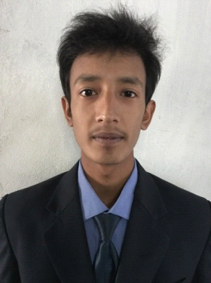

Manohar

E-Mail: Manohar.375546@2freemail.com
Mobile: Whatsapp +971504753686 / +919979971283

OBJECTIVE:
“Looking forward to join a progressive organization where I can pursue a successful career by utilizing my skills and abilities to the maximum extent with my full potential. Organization that recognizes and compensates the efforts and would provide me with the opportunity for career development and advancement.”

STRENGHTS:

- Costumer handling.
- Demonstrating my ability to react and perform well under pressure.
- Can work independently or within a team.
- Customer satisfaction.
- Well developed interpersonal and communication skills.
- Speaks fluently in English language.

Education Qualification

- Completed Intermediate from Sai Institute of Education & Research, Darjeeling, West Bengal, India.
- Completed High school from Sai Institute of Education & Research, Darjeeling, West Bengal, India.

Skills & Expertise

- Well versed in MS OFFICE SUITE (Word, Excel and PowerPoint), E-mail and Internet.
Trainings

- Handling complaints.
- Team building.
- Professional grooming and hygiene.

PERSONAL PROFILE

Date of Birth : 03.05.1994
Sex : Male
Nationality : Indian
Marital Status : Unmarried
Languages Known : English, Hindi & Nepali.

Visa Type : Visit Visa (valid till February)

DECLARATION

I hereby declare that all the above-furnished details are true and correct to the best of my knowledge

Date:

Place:

