CURRICULUM VITAE
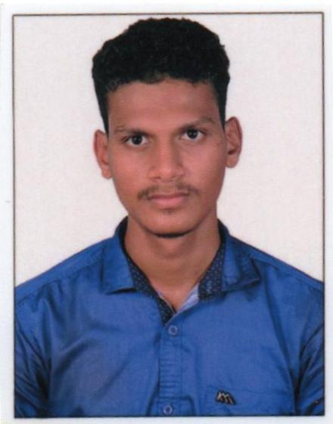

RAKSHITH
RAKSHITH.375656@2freemail.com

OBJECTIVE

To make a positive impact in my field of activity leading to Organization growth by creative application of my value based convictions and professional divinity by putting my all efforts in the work assigned to me in an organization where I can grow along with the organization.

PERSONAL STRENGTH

• Strong Inter-personal organizational skills.
• Sincerity towards job and punctuality.
• Able to cope under pressure.
• Can work independently or as a part of team.

ACADEMIC QUALIFICATION

- Mechanical diploma from NRAM Polytechnic Nitte, with First class in the year 2015
- 10th from Hindu Junior College Shirva, in the year 2012

WORK EXPERIENCE

Suzlon Wind Energy Pvt.Ltd. Padubidri, India
- Responsible for maintaining and repairing equipment required in the day to day working
- Assessment of the required tools for the maintenance of the equipment
- Assessing the needs of equipment replacements, spare parts
- Submitting the daily reports to the shift leaders.
- Responsible for working with personal protection equipment.
- Making the process routine charts.
Shri Kalikamba Auto Works, Kuthyar, Udupi, India
- Assist Automobile Mechanic in repairing automobile vehicles.
- Remove & disassembles unit, like engine, transmission, or differential, to be repaired, using hand tools power tools.
- Perform other duties as industry master title.
- Making the bills & maintaining the accounts of the workshop.
- Requisitions for vehicle brochures, promotion material, and supplies.
- Deal effectively with management, employees and outside contacts while working under pressure
- Fabricating materials with gas welding and electrical arc welding

COMPUTER SKILLS .
- MS word, MS Excel & C program.
- Solid Edge, Plc.

RELAVANT SKILLS .
- Working knowledge of AC
- Working experience with PPM & Corrective Maintenance
- Experience of plumbing and electrical circuits
- Working knowledge of ware house and store keeping.
- Fabrication, Fittings and Facility maintenance.

ACTIVITIES AND INTREST .
- Listening music, meeting with new people and a long journey with a bike.
- Watching movies, Reading books, Playing cricket and swimming.

PERSONAL PROFILE

- Date of birth : 26-03-1997
- Nationality : Indian
- Marital Status : Single
- Languages known : English, Hindi, Kannada, Tulu.

CERTIFICATION .

I, the undersigned, certify that the above statements are true to the best of my knowledge and belief.

Place: Dubai
Date: 20-12-2017

