Email: Vivek.375707@2freemail.com
Mobile: Whatsapp +971504753686 / +919979971283

Vivek, CPC.ICD-10 Certified.
Certified Medical Coder & Auditor

PERMANENT ADDRESS:
Village : Bakaha
City : Khalilabad
District : Sant Kabir Nagar
Uttar Pradesh - 272175
India

PERSONAL DATA:
Sex : Male
DOB : 08-Feb-1988
Religion : Hindu
Marital status: Married

LANGUAGE PROFICIENCY:
English & Hindi

PASSPORT DETAILS:
Date of issue : 21-10-2008
Date of Expiry : 20-10-2018
Place of issue : Lucknow

OBJECTIVE:
To work with an organization where I can explore my skills and abilities in the best possible way delivering quality work in the most challenging &creative environment.
SKILLS AND STRENGTH:
- Certified Professional Coder (CPC) with 5.5 years of experience in Medical coding with specialized expertise in Evaluation and Management of all specialties (Internal medicine, Gastroenterology,pediatrics,Orthopedic,Endocrinology,Gynecology, Ophthalmology, cardiology, etc).
- Good experience of E/D and facility coding
- Manage chart completion (ICD-9-CM , ICD-10 CM and CPT-4 ,HCPCS coding/abstraction) and patient information privacy/security
- Strong proficiency of physician coding, outpatient coding as well as facility coding, pre-approvals.
- Good knowledge of UAE specific insurance coding and HAAD Claims &Adjudication Rules.
- Expertise in various coding software like, 3M En-coder and En-coder pro, EMR and HMS, Meditech, Med host, HMS Insta .
- Efficiently utilizing MS Word, Excel, and PowerPoint for data management and presentations.
- A motivated and diligent team player utilizing excellent communication, interpersonal skills with strong analytical mind-set to learn quickly, to analyze the situation, identify requirements and provide solutions.
- Ability to Manage Multiple Tasks in a Pressured Environment Dedication and drive as a hard working individual.
ACADEMIC QUALIFICATIONS:
course | Institution | Year
D- Pharmacy | Dr. M.G. R Medical University, Chennai  Tamil Nadu | 2006-2008
Intermediate (10+2 ) | U.P. Board | 2005
High School ( 10th) | U.P. Board | 2003

Certifications: CPC (Certified professional coder) from AAPC. USA – March 2013.
ICD-10 CM certified from AAPC. USA – August 2015

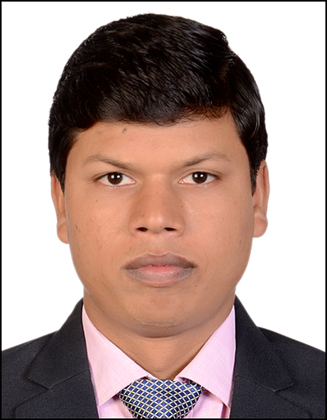

Professional Experience: Total 5.6 Yrs
- Overseas Experience :

Feb 2016 Still present NNMC Medical centre/National Hospital (AVIVO HOSPITALS GROUP) Abu Dhabi, UAE.
Medical coder & Auditor
- Manage chart completion (ICD-10CM and CPT coding/abstraction with E&M 1997 guidelines) and patient information privacy/security
- Work collaboratively with patient account department to ensure accurate billing and resolve claim denials and medical-necessity issues.
- Auditing the medical records and updating to coders.
- Approval and Pre-authorization activity for the procedure and other related conditions to the patients.
- Training involvement in Doctors training for insurance update and documentation deficiency in order to meet correct E&M coding to avoiding claim rejections.
- Experience and Lead role involvement of TASNEEF auditing process for HAAD in coding vertical
- Claim denials management.
- Claims Rejection.
- Claim Submission.

March 2014 to August 2014 American Hospital Dubai, UAE

Medical Records Coder

- Responsible for productivity and quality of coding activities
- Assigning ICD-10 and CPT codes for the medical records.
- Mapping the CPT codes with existing internal codes.
- Auditing the ICD-l0 codes assigned for outpatient records
- Updated myself and the facility RCM department for regular updates by DHA.

Feb 2015 to Jan 2016 ACS Global health Care Ltd. Noida, India
Specialist Medical Coder

- Manage chart completion (ICD-9-CM , ICD-10 CM and CPT coding/abstraction) and patient information privacy/security
- Work collaboratively with patient account department to ensure accurate billing and resolve claim denials and medical-necessity issues
- E&M, ER coding using 1995 guidelines.
- Done quality control for E/D & E/M coding and giving the feedback to coders and respective client.
- Multi-specialty and Surgery coding including Outpatient coding.
- Ambulance services and hospital facility coding.
- Providing training and updates to new trainee coders for multiple clients.

June 2013 to Jan 2015 Hexaware Technologies Mumbai, India
Specialist Medical Coder
- Manage chart completion (ICD-9-CM and CPT coding/abstraction) and patient information privacy/security
- Work collaboratively with patient account department to ensure accurate billing and resolve claim denials and medical-necessity issues
- E&M ER coding using 1995 guidelines
- Multi-specialty and Surgery coding including Inpatient/ outpatient coding.
- Ambulance services.
- Coding Audit- Auditing EM reports for Provider.UAE
- CPT and HCPCS code mapping
- ICD-10 coding for a leading provider in Dubai

May 2012 to June 2013 Gebbs Health Care solutions Ltd. Mumbai, India
Medical Coder

- Responsible for productivity and quality of coding activities.
- Played lead role to settle down the ED coding guidelines of the client for Quality coding
- E&M ,ER coding using 1997 guidelines
- In-Patient
- Office visits
- Consultation and
- Preventive care services and medicine coding using 1997 guidelines.

DECLARATION
I hereby declare that all the information given above is correct to my knowledge and I bear the responsibility for the correctness of the above mentioned particulars.

Place: Abu Dhabi Signature
Date

