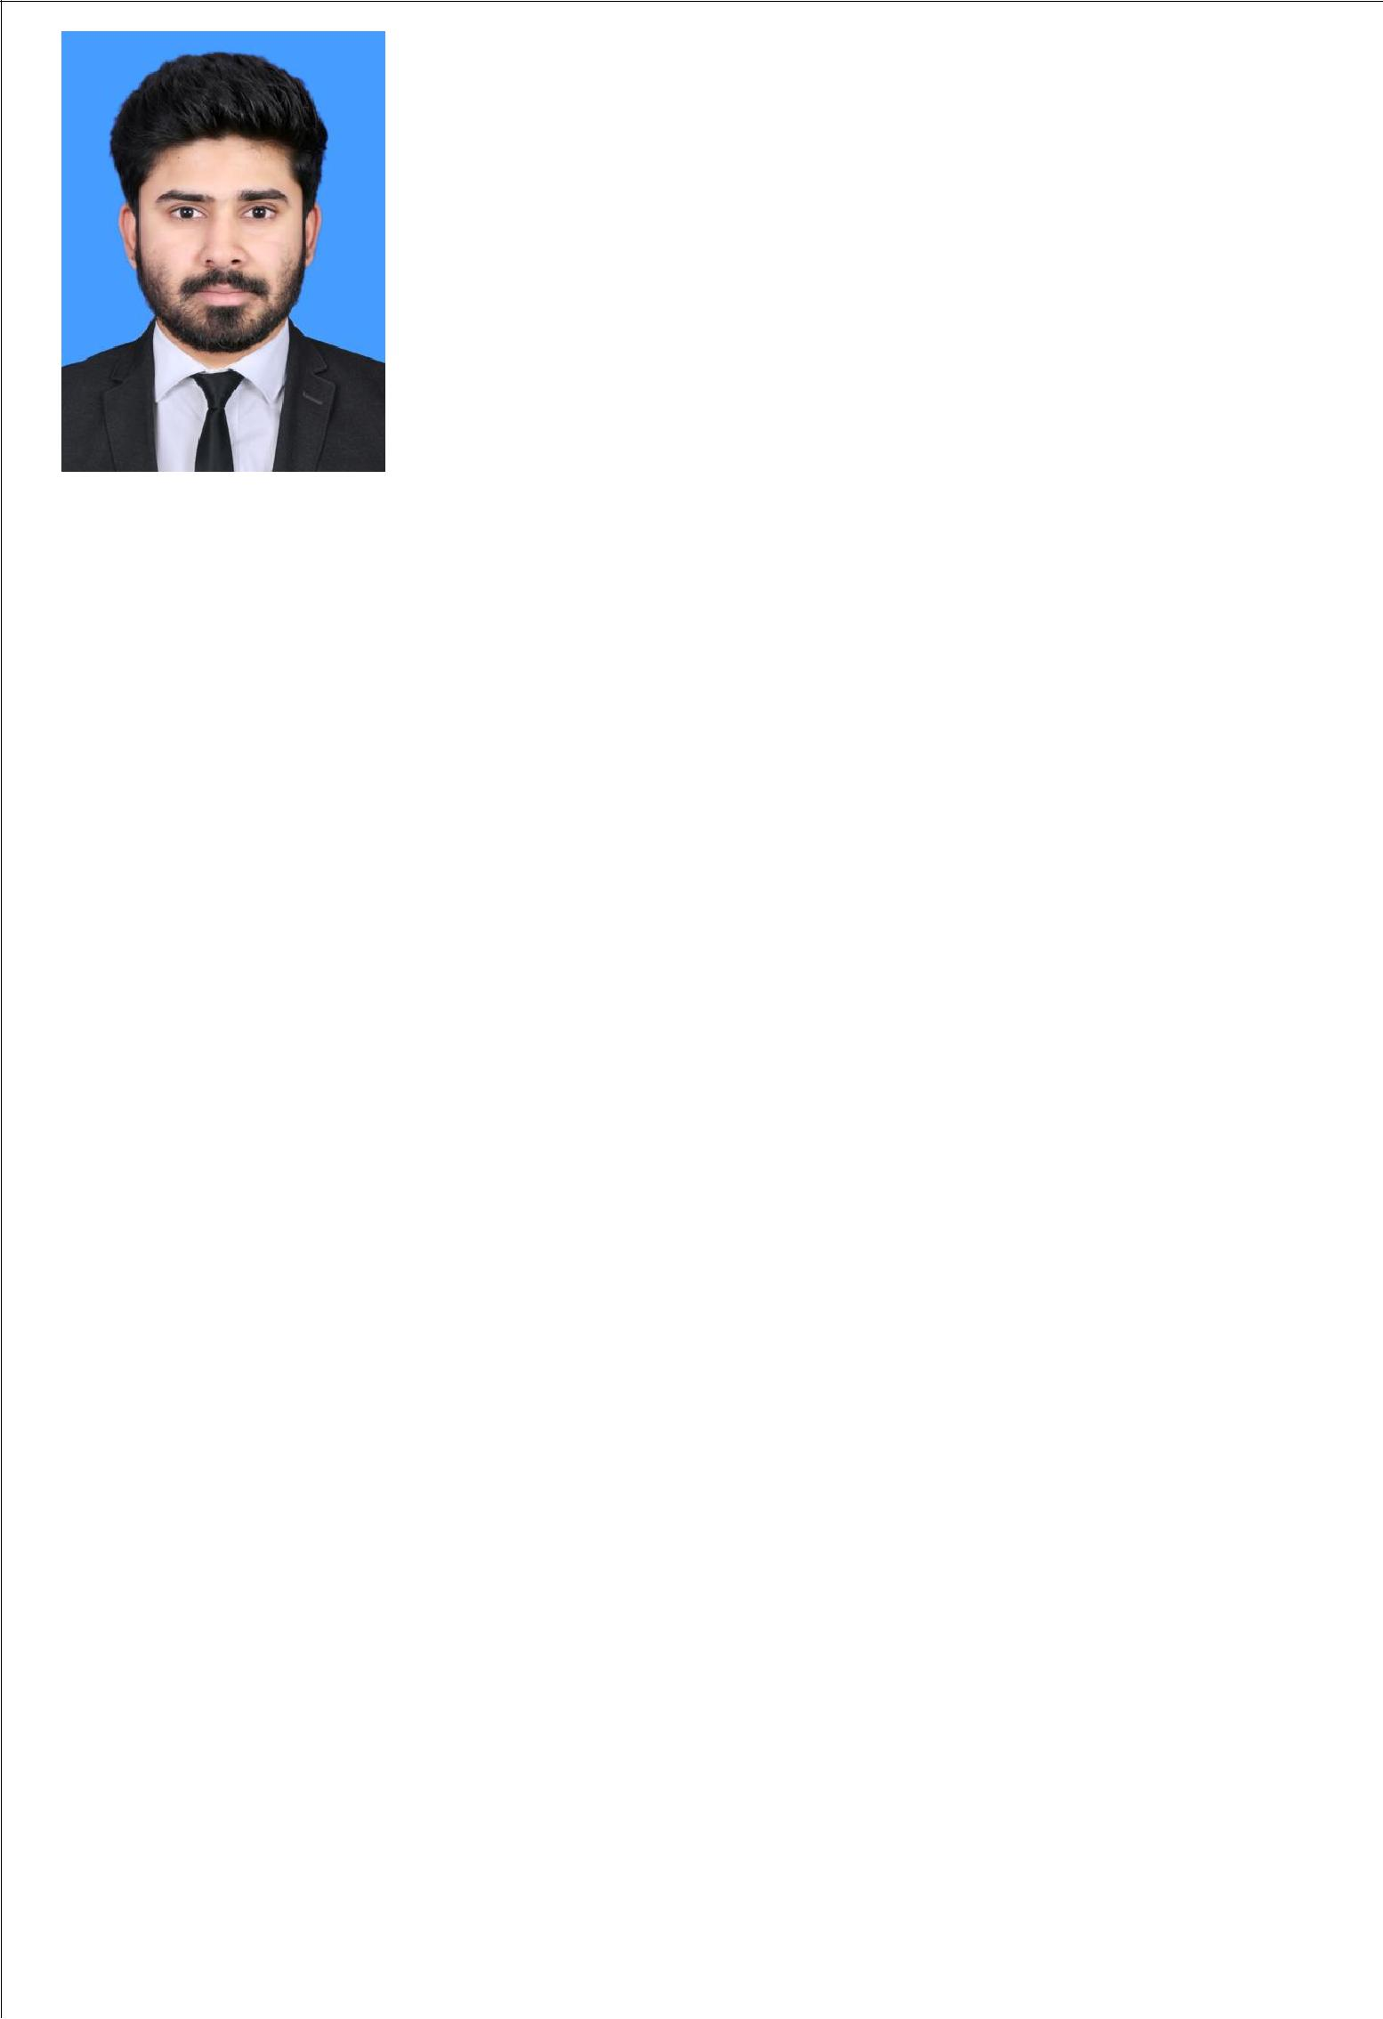

Personal Data

Date of Birth : 20-Jan-1993
Gender : Male
Nationality : Indian

Marital Status: Single

Language Proficiency
English
Arabic

Malayalam
Hindi

Tamil
Current place
Hawally, Kuwait

E-mail
MOHAMMAD.375715@2freemail.com
Mobile: Whatsapp +971504753686 / +919979971283

Address

Hawally,

Tunis Street

Street-106

State Of Kuwait
CURRICULUM VITAE
MOHAMMAD
Career Objective
To secure a full-time position in Mechanical Engineering, where I can apply my technical and personal skills and contribute to grow together with the progressive organization

Professional Summary:
BE.MECHANICAL ENGINEERING
M.B.A. PROJECT MANAGEMENT
Responsibilities.
- I will be a good asset to the Organization.

- I will work hard for the bright future of the Organization.

- I will give my level best effort to the Organization.
Work Experience (1Year 10 Months)
- Currently working as Calibration Engineer in Calibration Lab, Public Authority for Industries (PAI), Kuwait

  - Calibration of equipment's.

  - Processing for ISO 17025 Accreditation

- As Calibration and testing Engineer in NATIONAL TESTING CERTIFICATION COMPANY, Kuwait. (Feb,2016-Present)

  - Testing (Proof Load testing) and Inspection of lifting apparatus/Machines (Mobile/Fixed Overhead and under hung Cranes, Hoist, Car lift, Forklift, Aerial/ground ladder etc. as per ASME and BS standards

  - Welding Machine Calibration

  - Calibration of Mass, Balance, Volume, Dimensional, Torque, Temperature and pressure.
  - Familiar with ISO 17025 lab requirements and processing.

- Familiar with Calibration techniques and ISO 17025
Academic Credentials
Professional

- Pursuing MBA at Bharathiyar University Coimbatore In 'Project Management'

- B. E. in 'Mechanical Engineering' completed from Anna

University in Maharaja Eng. College, Avinashi, Tiruppur, Tamilnadu, India. 2010 to 2014 with 72% marks

Training Course

➢ Certified Calibration Professional Course from STQC Hyderabad.

Specialisation Courses

- QA/QC Engineering course From IIS Institute Cochin

- NDT Level-2 By ASNT–UltrasonicTesting,Penetrant Testing,Radiography Testing,Magnetic Particle Testing (UT,PT,RT,MT) Course From IIS Institute Cochin
- Basic Pipe Line Engineering Course From IIS Institute Cochin

Educational

- (Plus 2) -2 year course from Kerala State Educational Board, India. with 74%marks

- Secondary School Leaving Certificate conducted by Kerala State Education Board, India. With 86% marks
Areas of Interest
- As a Mechanical Engineer in an esteemed Organization.

- As an Project Management Officer in esteemed Organization.
- As a quality control engineer..

- As a Production Engineer in Production Industry.

- As a Office assistant position in an esteemed corporation.etc.
Projects Done
- Design And Analysis Of Turbocharger Impeller In Diesel Engine from Maharaja Eng. College, Avinashi, Tiruppur, Tamilnadu - 641654

- Design And Fabrication Of Foot Step Power Generator for Mini Project as part of syllabus
Personal Traits
- Positive attitude and willingness to take responsibilities.

- Confident, Hard work, Keen observer and optimistic.

- Possess pleasant manners.
Practical skills
- Good written and interpersonal skill able to follow standard operating procedures.
- Intermediate level computer skills.

- Good manual dexterity.
Personal Qualities
- Good interpersonal and communication skills.

- Able to work to a schedule and meet deadlines.

- Able to remain calm and confident under pressure

- Pays attention to detail.

- Problem solving.

- Able to maintain satisfactory level of attendance.

Software Skills
- Basic CADD/CAM, ANSYS, PRO-E

- MS Office.

- Internet and Mailing

Hardware Skills
- Computer Hardware Maintenance

Interests & Hobbies

- Playing Football
Declaration

I hereby declare that all the above details furnished by me are true to the best of my knowledge

Place: Kuwait MOHAMMAD

