Mohamed
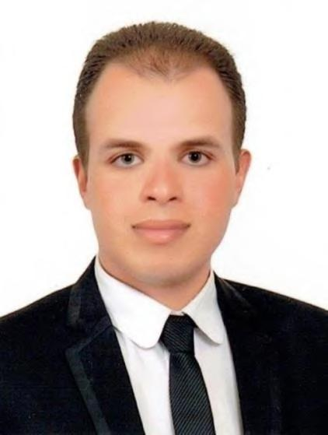
Medical Sales Representative

- E-Mail: mohamed.375753@2freemail.com

- Nationality: Egyptian.

- Date of Birth: January 11st, 1990.
- Visa: Visit valid to Jan 30th, 2018.
- License: International Driving.

- Marital Status: Single.

- Military Service: Completed.

Education

- Bachelor’s Degree in Pharmaceutical Sciences, Suez Canal University “2013”.

- American Board of Clinical Pharmacotherapy 2016 “In Progress”.

- Arabic-Degree: Mother Language.

- English-Degree: Good Command in Spoken and Written.

 | Work Experience
A. Liptis Egypt for Pharmaceuticals | January 2017 – October 2017 (10 Months)
I. Medical Rep. in Port Said, Egypt. | January 2017 - June 2017 (6 Months)

- Promotion of Dorofen “Market Leader of Osteoarthritis” with Orthopedic Surgeons.

- Promotion of Vaxato “Rivaroxaban: Oral Anticoagulant” with Orthopedic Surgeons.

- Launching Doxanero “Agomelatine: Antidepressant” with Neurologists and Psychiatrics.

II. | Product Specialist in Suez Canal Zone, Egypt. | July 2017 – October 2017 (4 Months)
1. | Promotion of Vaxato “Rivaroxaban: Oral Anticoagulant” with Orthopedic Surgeons.
B. | Global Napi Pharmaceuticals | December 2014 – December 2016 (2 Years)
I. | Medical Rep. in Port Said and Damietta. | December 2014 – December 2015 (1 Year)

- Promotion of Disartan “Valsartan: ARB for Hypertension” with I.Ms and Cardiologists.

- Launching Tensoplerone “Eplerenone: Diuretic” with I.Ms and Cardiologists.

- Promotion of Hexagabalin “Pregabalin: Neuropathic Pain Killer” with Neurologists.

- Promotion of Articu-Safe “Diacerein: Chondroprotective” with Orthopedic Surgeons.

II. Medical Rep. in Port Said and Ismailia, Egypt. January 2016 – December 2016 (1 Year)

- Promotion of Cortiplex “Vit. B12: Antiemetic” with Pediatrics.

- Promotion of Carnitol “L-Carnitine” with Andrologists and Pediatrics.

- Launching Shorsalin “Oxacarbazepine: Antiepileptic” with Neurologists and Psychiatrics.

- Launching Fortamind “Citicoline: Psychostimulant” with ICU and Neurologists.

- Promotion of Terbin “Terbenafine: Antifungal” with Dermatologists.

- Promotion of Dermatop “Prednicarbate: Topical Corticosteriod for Eczema” with Dermatologists.

- Launching Ebastel “Evastine: Antihistamine” with Pediatrics.

C. Sanofi-Aventis July 2012 – September 2012 (3 Months)

- Trainee Medical Representative for Promotion of Novalox Line in Port Said, Egypt.

- Novaldol “Paracetamol 1000 mg” as Analgesic and Antipyretic.

- Maalox “Aluminum Hydroxide, Magnesium Hydroxide and Simethicone” as an Antacid.

➢ Institutions

I. Suez Canal Authority: Consider the 2nd Bulk Institutional Business in Egypt.
  - Launching Disartan “Valsartan: ARB for Hypertension” with I.Ms and Cardiologists during 2015.

  - Launching Terbin “Terbenafine: Antifungal” with Dermatologists during 2016.

  - Promotion of Dermatop “Topical Corticosteriod for Eczema” with Dermatologists during 2016.

  - Promotion of Dorofen “Glucosamine Sulfate: Chondroprotective” with Orthopedics during 2017.

II. Health Insurance: Promotion of Dorofen with Orthopedic Surgeons and I.Ms during 2017.

Training Courses

- International Computer Driving License “ICDL” 2010.

- Pharmacist Creative Program Sessions by “Pfizer” 2011.

- Future Access Internship Program by “Sanofi Egypt” 2012.

- Selling and Presentation Skills by “Global Napi” 2015.

- Advanced Selling Skills by “Liptis Egypt” 2017.

