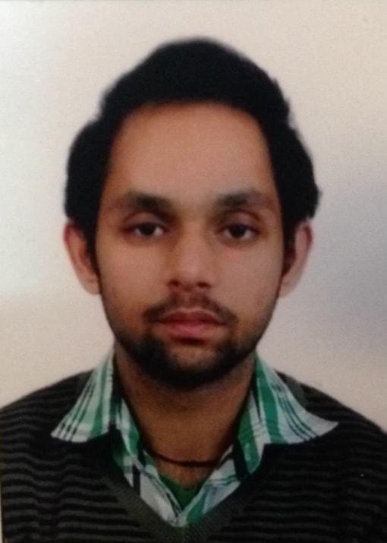
Amandeep
E-mail: amandeep.375771@2freemail.com

OBJECTIVE:
To obtain a desktop support technician position and apply my technical skills in providing a single point of contact for end users to resolve issues related to PC Software and hardware.

Professional Experience
4 year’s Experience with Edge Infotech as Desktop Support Engineer.

Edge Infotech
September 2013 – November 2017

- Responsibilities
- Providing clients with software and hardware configuration according to the business requirements
- Liaising with vendors and making purchase for hardware equipment
- Supervising installation and test systems to ensure functionality
- Identifying conflicts and providing effective solutions to minimize repetition of similar conflicts
- Creating and providing employee login ID and password to each workstation

Education and Training
Academics
- Bscit
Kuvempu University
- 12th Class
Khalsa School
- 10th Class
Guru Nanak Public School

Language Known

  - English
  - Hindi
  - Punjabi

Computer Skills

- Installation, Upgrade and update of Windows and Apple Operating System
- Microsoft Certification in .Net and GUI
- Desktop Computer Hardware Assemble and Troubleshoot
- Fix Windows Operating System Software Related Issues
- Fix Apple Operating System Software Related Issues
- Fix Apple IOS and Android Software Related Issues
- MS Office/Excel 2007/2010/2013
- HTML
- Knowledge of various switches, routers, firewalls, antivirus software, etc.
- Knowledge of various band of printers and fix printer related issues
- Create and manage user accounts and group policies for company employees from Windows Server 2012 r2

Summary of Skills:
- Comfortable in working independently as well as a team member
- Excellent multitasking, problem solving and resource management skills
- Passionate to acquire new skills and adapt them to deliver results
- Excellent time-management and communication skills
- Confident and patient worker with an ability to develop and maintain professional rapport with colleagues and clients through effective communication

