Moustafa

Email: [moustafa.375781@2freemail.com](mailto:mostafa.hamdoun@outlook.com)

**Objective:**

Recent accountant graduate looking for position in accounting and  
finance where I can utilize my skills put my learning into practice and  
makes a contribution I am eager to learn and excited about beginning  
my career in the dynamic industry.

|  |  |
| --- | --- |
| Educations: | |
| University: Specialization: Gradation year: | Damnhour University.  Bachelor of commerce - Accounting Division. May 2016. |

**Experience and** courses:

Work as a junior accountant in travel agency from  
10th of Apr 2017 to 30th of Nov 2017 and my  
responsibility was salary's, taxes, call center and  
Record daily financial transactions.

Work as a data entry in Qatar from 9th of Dec 2016  
to 6th of Mar 2017 and my responsibility record bills  
vendors in program quick box.

Training in accounting office from 1sl of Aug 2016  
to 24th Nov 2016 and my responsibility was  
salary's and reviews some balance sheets.

Training on program Peachtree from Internet.  
Course Accounting Excel.

ICDL

English accounting level four.

Certificate Export and Import.

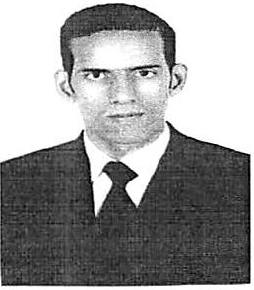

|  |  |
| --- | --- |
| Skills: | • Good user for MS office programs. |
|  | • Good user for computer and Internet. |
|  | • Use scanner and printing. |
|  | • Honest. |
|  | • Hard working. |
|  | • Fast proceed. |
|  | • Work individual and with team. |
|  | • Intelligent. |
|  | • Eager to learn. |
|  | • High attention. |
|  | • Working under stress and pressure. |

|  |  |
| --- | --- |
| Lanauaae: | • Arabic: Mother tongue. |
|  | • English: very good. |

Reference:

Available upon request with a tourist visa.

|  |  |
| --- | --- |
| Habits: | • Football. |
|  | • Chess. |
|  | • Tennis. |

|  |  |
| --- | --- |
| Personal Information: | |
| Name: | Moustafa |
| Date of birth: | 03/03/1993. |
| Marital status: | Single. |
| Nationality: | Egyptian. |

Thank you for your value time and hope hear from you in near future.