CURRICULUM VITAE
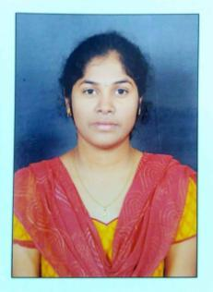

SRAVANTHI

Mobile: Whatsapp +971504753686 / +919979971283
Email: sravanthi.375697@2freemail.com

Objective:

Dependable and professional Medical Claims Processor with 3 years experience in processing and coding claims, ensuring all required criteria are met before eligible payments go out. Track record of meeting targets through significant knowledge of medical and insurance industries and terminologies. Ready to use skills for high level of customer service for companies and clients.

Highlights:

- Auditing for overpayments

- Claims adjustment

- Quality assurance

- Daily, weekly, monthly reports

- Proficient with claim processing software

Experience:

01 August 2014 to 31 July 2017 Poseidon Software Solutions Private Limited, Pune,

Assistant Claims Processing Executive.

- Processed assigned claims.

- Inspected apt allocation of deductibles, co-pays, co-insurance and reimbursements.

- Resolved issues involving customer complaints and claim adjudications.

- Investigated overpayments and funds requirements.

- Kept record of phone calls.

- Take claims information, log them into system and generate reports

Education:

Course | Specialization | Name Of The | Board/ | Year of | % of
 |  | Institution | University | Passing | marks
B. Tech | Electronics and | CHAITANYA | JNTUA | 2014 | 78.27
 | communication | BHARATHI
 | Engineering | INSTITUTE | UNIVERSITY
 |  | OF | A.P.
 |  | TECHNOLOGY
 |  | SRI | BOARD OF
 |  | CHAITANYA | INTERMEDIATE
INTERMEDIATE | Maths physics | JUNIOR | EDUCATION | 2010 | 85.4
 | chemistry | KALASALA, | A.P.
 |  | HYDERABAD
 |  | ADITYA HIGH | BOARD OF
S.S.C | _ | SCHOOL. | SECONDARY | 2008 | 93.3
 |  | PRODDATUR. | EDUCATION
 |  |  | A.P.
Strengths:

- Quick Learner
- Hard Worker

Skills:

- Packages: Ms Office.
- Programming Languages : C, Corejava basics

- Operating System : windows Xp or 7

Declaration:

I here by declare that the above details furnished by me are correct up to my Knowledge and I bear the responsibility for the correctness of those details.

