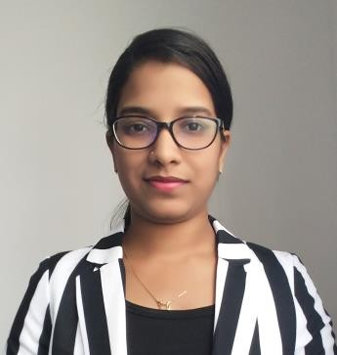
POOJA
Mobile No: Whatsapp +971504753686 / +919979971283
E-mail: Pooja.376018@2freemail.com Born on 11th March’95, INDIA Languages known: English, Hindi, Marathi
Visa Status: Visit visa valid till 25th Jan,18

I learned to always take on things I had never done before. Growth & comfort do not coexist; Life will only change when you become more committed to your dreams than you are to your comfort zone.

Objective

Outgoing communicator with a brilliant educational background in Human Resources Management. Exceptional ability to handle HR work in a professional manner. Thorough understanding of the importance of external and internal communication protocols. Proficient in comprehending and analyzing information derived from human resource documents. Profound ability to oversee recruitment efforts and ensure employee retention.

Personality Trait

I am a person with full of zest and vigor and would like to take up challenges and fulfill them to the Best of my abilities and live up to my dreams and Expectations.
Personally, I believe that my die-hard attitude will contribute towards positive thinking in a vast group. My relationship with others is the biggest positive character that is embedded in me and will stand me in good stead in any Organization.
And I seek opportunities to work in an environment which is offering a career development in 360 degree and to take up challenging assignments where I can contribute to the organizational growth.

Academic Credentials: (From India)
- Masters of Business Administration / Masters in Management Studies (HR) from Mumbai University.
- Graduate with BSc I.T from Mumbai University.

Skill Sets:
Competencies:
- Analyze and interpret complex information
- Presentation and marketing skills
- Good knowledge of HR policy and procedures
- Able to analyze and interpret complex information
- Able to deal with highly confidential matters professionally & discreetly
- Large client Relationship management.

Personal:
- Excellent organizational skills with an ability to think proactively and prioritize work
- Multi-tasker, Effective organizer & planner
- An intense work ethic which is Punctual and reliable
- Dedicated, loyal, diligent with a tidy manner.
- Good written and verbal communication skills
- Ability to manage conflicting demands
- Well versed with MS office.

WORK EXPERIENCE - INDIA

LIONS TINY TOTS ENGLISH MEDIUM SCHOOL & JR. COLLEGE, KHED, INDIA.

LECTURER-
- Teaching the students the subject of INFORMATION TECHNOLOGY under the payroll of the institute / college since 1 year and months.
- Providing classroom training for students till std. 10 student.
- Arranging examinations for students.
- Creating teaching schedules for students with the school management.

KRISHLEX POLYMERS PVT. LTD.,
( 2 months)
Human Resources Intern-

- Maintained and updated employee files and training records and learning the company’s process in managing resources.
- Processed newly recruited and terminated employee files
- Assisted interviewing committee
- Made placement suggestions

I hereby declare that the above given information is authentic to the Best of my Knowledge and I am looking forward for a successful career that helps in achieving my personal and professional development.

Ms. Pooja

