Curriculum vitae
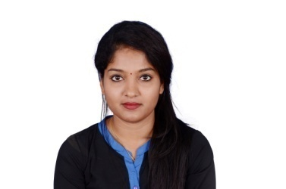
Miss Priyanka
Address - Dubai, UAE
E-mail - Priyanka.376110@2freemail.com

Objective:-
Seeking a challenging position to utilize my skills & ability in areas which offers a professional growth while being resourceful, innovative & flexible.
Profile Summary:-
- Over all experience in working for Mortgage Banking, BPO handling voice/non-voice process, Quality Analysis(QC),Subject Matter Expert(SME) .
- Excellent track record in customer service.

Professional Experience :-
- Cognizant Technology Solutions- Senior Process Exceutive(QC and SME) -2011-2017
Job Description
- US Mortgage Loan and Tax Verification.
- Loan Research - Verification and updating customer loan and tax information.
- Legal Verify - Validation of property legal description.
- Pre Cycle Audit –Verification of Loan information before tax payment cycle audit ensuring accurate amount of taxes are paid to the right customer.
- Making desired changes in TALON.
- SME(Subject Matter Expert )-Mentoring new joiners, Giving training to new joiners on basis of work and checking the inventory on daily basis and clear it on time.
- QC- (Quality Analysis)-Monitoring and auditing the quality of production team.
- Assisting Team Members to ensure that quality is consistent and making sure that there is no room for error and client escalations.

- I-Search Private Limited Mangalore- as a Online Support Executive (2010-2011)

Job Description
- Maintain team, customer services & facilities.
- Maintain stock, supplies and inventories.
- Solving web application issue by using Trouble Shoot.
- Giving online Training to customer.
Academic Qualifications:-
Bachelor of Computer Application (BCA) Mangalore.
Pre University Certification, PU board, Mangalore.
SSLC, Vidyadayinee High School, Mangalore, Karnataka Secondary Education Board.
Computer Knowledge:-
- Detailed Computer Operation in MS office, Data entry & typing.
- Internet Browsing & computer program installation.
Personal Details:-
Date of birth : 13.03.1990
Nationality : Indian
Marital Status : Single
Languages known : English ,Hindi & Kannada.

Declaration:
I hereby declare that the above information given by me is true to the best of my knowledge.
Yours faithfully,
Priyanka

