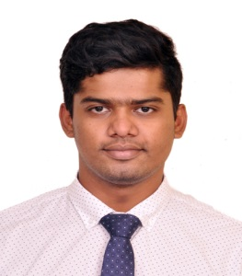
SHELDON
Sheldon.376360@2freemail.com
+971504753686 / +919979971283

CAREER OBJECTIVE:-

Looking forward for Masters in Finance, and secure a responsible position in a growing, technologically driven organization that will challenge my skills & utilizes it.

EDUCATION:-

M.B.A(Finance) From Athena School of Management Powai- (Mumbai) | (2016/18) |  | Pursing.
TYB.com From University of Mumbai. |  | (2014/15) | 68.71%
HSC From Maharashtra State Board. |  | February-2012. | 70.33%
SSC From Maharashtra State Board. |  | March-2010. | 69.45%

WORK EXPERIENCE:-

- Interned at H&R Block
- Worked as intern for Two Months (July-September 2017) on “Business Development for Client Acquisition- GST”

- Interned at ICICI Securities
- Worked as intern for Two months (April-May 2017) on “Client Awareness project on Mutual Fund Simplified through icicidirect.com”

- Interned at Edelweiss Financial Service
- Worked as intern for Two months (October-November 2016) on Wealth accumulation and client acquisition.

- CAT King Leadership Program
- Sales and Business.
- Leadership skills and techniques.
- Worked with faculty of Harvard Business School.

STRENGTHS:-

Good communication skill, ability to adapt working conditions and background. Quick decision making.

HOBBIES:-

Listening music, sports, traveling.

PERSONAL DETAILS:-

Languages known- English, Hindi and Marathi.
Date of Birth- 12/09/1994
Marital status- Bachelor.
Religion- Catholic.

SHELDON

