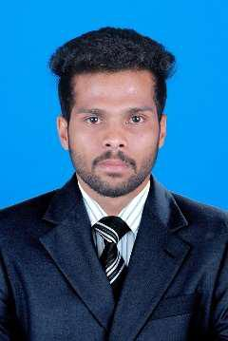
ZUHAIL

Profession
Email Id
C/o-Phone

Passport NO
Visa

Career Objective

- Automobile engineering
- Zuhail.376528@2freemail.com
- +971501685421
- Deira, Dubai, UAE

- Visit

Seeking a career that is challenging and interesting, and lets me work on the leading areas of technology, a career that gives me opportunities to learn, innovate and enhance my skills and strengths in conjunction with company goals and objectives.

Career History

AM Motors (Suzuki Authorized Service Center) – Tirur, Kerala

Automobile technician August 2014 – November 2017

Worked to with utmost sincerity and discipline to provide quality services to the customer as per the Suzuki’s guidelines and as per the organizations policy.

Achievements

- Two time winner of best mechanic award by AM Motors.
- Won school level price for drawing.

Skills

- Well-organized, Efficient, Self-motivated, assertive and a quick learner.

- Keen to learn.

- Work well with a diverse group of people and in a team.

- Honest, friendly, excellent communication skills.

Educational Qualification

Standard | Institution | University/Board | Year | CGPA/Percent
 |  |  |  | age
₁₀th | Government higher | Kerala SCERT | 2010 | 62%
 | Secondary School,
 | Puthuparamba
12th | Government higher | Kerala SCERT | 2012 | 66%
 | Secondary School,
 | Puthuparamba
ITI | AMINA ITI | State board of | 2014 | 69%
 |  | technical
 |  | education,kerala

Project

Repair and modification of an old maruti omni in to a new look.

Personal Information

Date of Birth
Sex
Marital Status
Nationality

Languages known

Hobbies

: 01-02-1995
: Male
: Single
: Indian
: English, Hindi, Malayalam,

: Drawing , watching movies, reading

Declaration

I hereby declare to bear the responsibility for the correctness of the information given in this resume.

(ZUHAIL)

