CURRICULUM VITAE

SRINIVAS
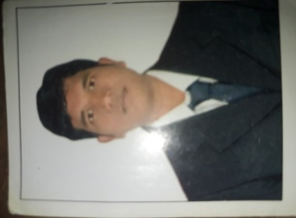

C/o-Contact :- +971505891826

Email Id : srinivas.376671@2freemail.com
________________________________________________________________________

CAREER OBJECTIVE :-
- To work within a challenging environment in a position of Housekeeping Attendant where I can utilize my skills and talents to achieve excellence in improving myself.

EDUCATION QULIFICATION :-
- Passed 12th HSC Exam
- Passed 10th SSC Exam

HOBBIES :-
- Listening Music.
- Playing cricket

WORK EXPERIENCE :-
- Worked 2 Years with Millennium & Copthorne Sharjah-UAE, as a Housekeeping attendant from 17th November,2014 to 24th November,2016 .
- One year experience in Tulip inn continent as a Housekeeping attendant in Hyderabad from 5th February to 15th October,2014.

HOUSEKEEPING SYNOPSIS:-
-Have proper Knowledge of all the housekeeping department, done all 3 shifts in absence of Housekeeping supervisor handled night and afternoon shifts.
-Follows operational and shift change procedures and tasks.
-Performs daily deep cleaning of guestroom, storage areas and laundry areas as assigned by the Housekeeping Supervisoror Executive Housekeeper and in accordance to the standards and procedure of hotel
-Sets up and organizes all furniture and aminities in guestrooms according to the hotel standards.
-Greets guest, responds effectively to guest concerns and requests.Follows up to ensure guest satisfaction.

PERSONAL INFORMATION :-
Date of Birth : 14 Oct 1990
Sex : Male
Nationality : Indian
Language Known : Hindi, English & Telugu.
Marital Status : Married.
Religion : Hindu

PASSPORT DETAILS :-

Date of issue : 27/01/2014
Date of Expiry : 26/01/2024
Issue place : Andra pradesh

DECLARATION :-

I declare with full concern that all information mentioned above by is true and Up to date to the best of my Knowledge.
(SRINIVAS)

