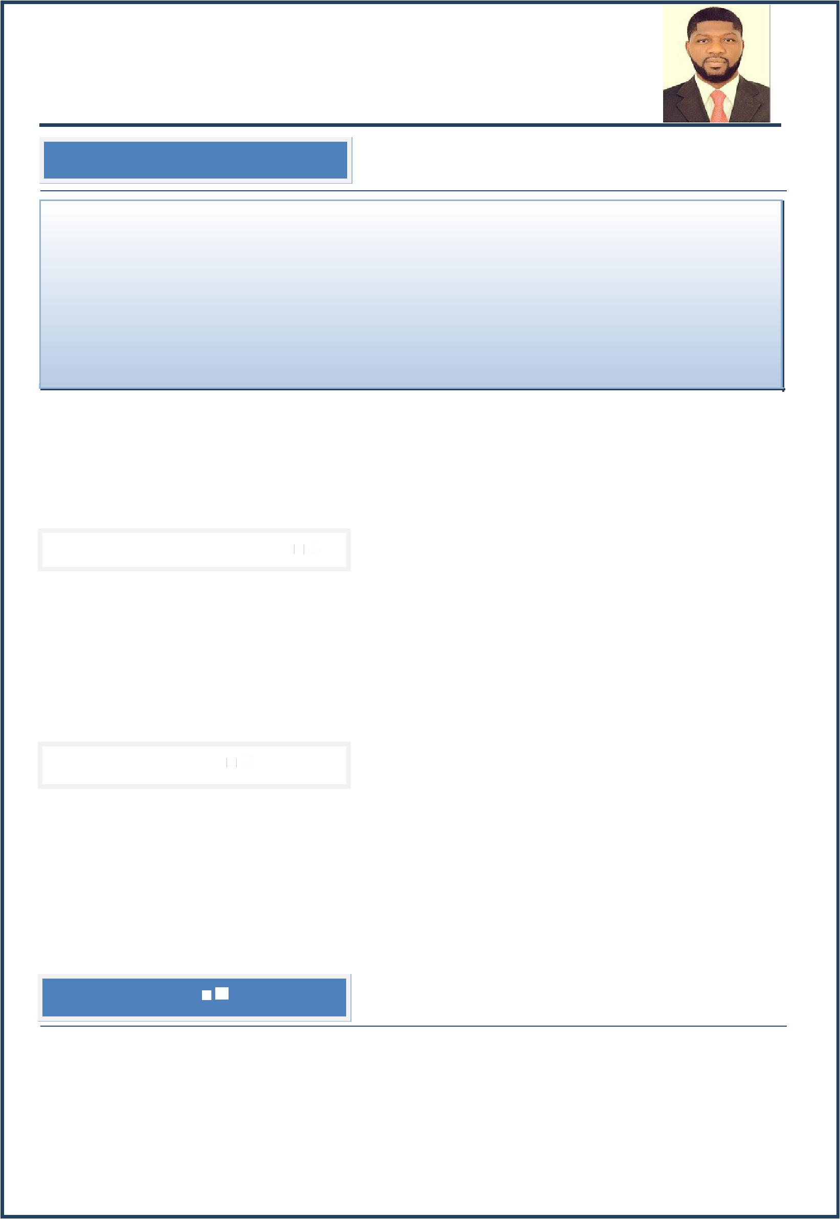
Opeoluwa

Sales & Marketing / Business Development Professional

Valid UAE Driving License

E-mail: opeoluwa-376678@2freemail.com

Profile Synopsis

Versatile, Dynamic and Gulf experience Professional equipped with 9+ years record of delivering top-quality performance and track record of significant contributions towards continued business growth. Manifest robust competency in managing a wide range of duties in domains of Sales & Marketing, Business Development, Portfolio Management, B2B, B2C, Territory Management, Accounts Management, Business Operations, and Client Relations. Track record of exceeding sales objectives, delivering results under stiff competition and providing ongoing service leading to add on sales and long-term customer’s loyalty. Highly motivated and effective team leader, who has achieved sales goals and delivered highest standards with the ability to monitor market and sales trends to make effective plans hence maximize the profits; Adapts easily to changes with excellent know-how of networking with key decision makers. Possess excellent analytical, problem-solving, negotiation, presentation, decision making, organization, time management, communication and interpersonal skills. Seek a challenging work profile where gained skills, expertise, and industry knowledge will have a valuable impact.

 | Strengths & Skills
 | Gained 9+ years experience within diversified industry |  | Expertise in Sales & Marketing / Business Development
 | Vast exposure in Real Estate, Telecom & Insurance |  | Strategic Planning and Business Development Skills
 | Market Insights/Lead Generation/Revenue Achievements |  | Excellent Up-selling/Cross-selling/Presentation Skills
 | Aptitude in Business Administration/Organizational skills |  | Market Research – Competitors Analysis Skills
 | Negotiation/Communication/Interpersonal skills |  | Result-oriented – Enthusiastic – Out of the box thinking
 | Educationai Quaiifcation
 | Master's Degree in Business Administration (MBA) – Lincoln University College, Malaysia |  |  |  | 2017
 | Bachelor's Degree in Economics – Adekunle Ajasin University, Akungba-akoko, Ondo-State, Nigeria |  |  |  | 2008
 | Professional Development:
 | National Security & Safety Institute Training – Edith Cowan University, Australia, ECU Emirates Center |  |  |  | 2013
 | National Diploma in Business Administration – Federal Polytechnic, Ilaro, Ogun-State, Nigeria |  |  |  | 2004
 | Carleler Snapshot
 | Operations Executive |  |  | Sep 2013 – Present
 | Sales & Leasing Consultant – Hamio Leasing & Real Estate Co., Nigeria |  |  | Feb 2012 – Jul 2013
 | Customer Service Representative – Airtel Nigeria (Spanco BPO), Nigeria |  |  | Feb 2010 – Jan 2012
 | Direct Sales Executive (DSE) Supervisor – Visa-fone Communications, Nigeria |  |  | Jan 2010 – Jan 2011
 | Marketing Exe/Business Development Officer – Union Assurance Co., Nigeria |  |  | Jan 2009 – Dec 2009

Achilevlemlents

Gained 9+ years experience in UAE and Nigeria in domains of Operations Executive, Sales & Leasing Consultant, Customer Service, Sales & Marketing, Business Development and B2B-B2C.
Accomplished Master's Degree in Business Administration (MBA) and Bachelor's Degree in Economics from one of the reputed University.
Successfully achieved assigned sales targets consistent with company standards and achieved best performance parameters as well as organizational goals and objectives.
Consistently demonstrated resourcefulness and initiative in support of top management with flexibility in working well in cross-functional teams.

Page 1 of 3

Performed assigned workload with indefinable enthusiasm, commitment, honesty, and dedication and drove towards contributing to continued business growth.

Corle Completlency

Sales & Marketing Management

Develop new sales opportunities and manage the full negotiation and close process with clients from start through sales closure. Sells products by establishing contact and developing relationships with prospects; recommending solutions.
Perform sales & marketing activities effectively to strengthen the company’s image in assigned territory, maintain business volume and gradually speed up business growth.
Accountable for ordering the correct volume and mix of product to service the outlets to the agreed company standards. Identify market potential in order to establish a new account, achieve sales volume, revenue/profitability goals.
Maximize volume and revenue in key assigned service accounts by utilizing fact-based selling methods. Effectively manage to acquire new service accounts for the company.
Maintain, monitor, and regularly evaluate pricing and contracts with customers to provide products and services that meet standards of quality, timeliness & cost. Achieve all revenue targets & objectives in line with the Area Business Plan.
Provide effective reporting & analysis of sales and forecasting of monthly sales plan. Analyzing market intelligence (Brands, market share & competitors activity).
Identify product improvements or new products by remaining current on industry trends, market activities & competitors. Contact clients by phone to negotiate terms of an agreement and conclude sales. Review own sales performance and
strategize on how to make proper and effective improvements.

Business Development Management

Support and enhance the company’s' initiative, focusing on priority industry clients, market trend analysis, and opportunity pursuit. Develop and executing industry business development plan and strategy with key metrics.
Strategize & interface with internal stakeholders on proposed industry marketing initiatives & client development projects. Research, analyze, and report on high-level trends and developments impacting the industry.
Identify new business opportunities as well as customized thought leadership responses.

Facilitate client relationship management by understanding priority clients’ current work, key contacts & practice offerings Advise internal stakeholders on relationship-building strategies. Monitor priority clients’ business, movement within
clients’ organization, and other developments. Identify cross-selling opportunities to expand client relationships.

Establish and facilitate client partnership opportunities including CSR, diversity, and thought leadership programs.

Organize and coordinate events, client training, and conferences. Document industry-specific experience and credentials and ensure content is kept current.
Develop, editing, and disseminating materials including pitches, proposals, and RFP responses.

Liaise with various Firm departments including Finance, Office Services, and IT to carry out firm-wide initiatives. Provide a high level of client service excellence to stakeholder, professional, services teams, and clients.

Provlen Job Roile

Operations Executive – Al Falah Groups (Subsidiary of Knights Bridge Global Co. Dubai)

Responsible for all business operations and maintaining security in the workplace. Provide instructions to co-workers on their assigned tasks.
Prepared daily operations and security reports and forward them to higher management as well as preparing performance reports on the assigned task.
Supervised the operational tasks and ensure the operations are going smoothly as per the plan without any delays. Developed strategies to improve the performance of every department in the company from time to time.
Established cost-effective solutions to enhance revenue and ensure the completion of assigned tasks on time.

Sales & Leasing Consultant – Hamio Leasing & Real Estate Co., Nigeria

Ensured to complete all necessary documentation associated with listing and selling properties including preparation and execution of sales agency agreements.
Provided regular written and oral feedback to vendors on market indicators and buyers’ interest. Completed and keep the current compulsory checklists. Conducted market appraisals for prospective vendors.
Supported the organization to gain a better market share by identifying, recommending and implementing improved selling and marketing strategies.
Identified further business opportunities through effective liaising with other related businesses and colleagues.

Ensured that the potential customers are provided with reliable and accurate advice and support regarding property movements and industry trends.
Maintained an understanding of both local and national real estate markets. Demonstrated excellent performance thus achieves individual targets as set by the management.

Customer Service Representative – Airtel Nigeria (Spanco BPO), Nigeria

Administered the highest standard by answering the phone in a professional manner and demonstrate good image for the company through phone interaction with new and existing customers.
Provided advice, assistance, and information to customers. Resolved all enquirers and complaints in a timely manner.

Ensured that all telephone calls are answered promptly dealing with customers queries, request, orders or complaints following up customers by calling them back.

Page 2 of 3

Researched required information for callers using available resources. Involved in processing orders, forms & application Sent emails to clients and answer their inquiries and fixed appointments if necessary.

Direct Sales Executive (DSE) Supervisor – Visa-fone Communications, Nigeria

Maintained and develop a good relationship with customers through personal contact, meeting face to face or via telephone. Acted as the first point of contact between the company and the current market/future market.
Displayed efficiency in gathering market and customer information to enable negotiations regarding variations in prices, delivery and customers specifications to their managers.
Supported the management of forth-coming products and discuss special promotions. Reviewed their own performances and aim at exceeding their targets. Recorded sales and order information and report them to the Sales Department.
Sent daily reports for evaluation. Develop new marketing strategies for the company’s products. Provided accurate feedback on future buying trends to their respective employers.

Marketing Exe/Business Development Officer – Union Assurance Co., Nigeria

Developed business relationships and services by prospecting new customers, profiling to identify current and future needs and maintaining a professional and attentive relationship with the focus primarily on business and cross-selling and other affiliate products and services.

Contacted customers to determine loan, deposit, insurance and investment needs. Sells products and services that meet identified needs according to the company's pricing and fee schedule.
Met with prospects and customers to achieve sales and cross-referral goals. Develop a personal plan to achieve assigned sales goals. Maintain strong business relationships.
Coordinated with other internal business development personnel to exchange prospect information as appropriate.

Represented the company at customer-oriented business groups and civic organizations to develop referral network and enhance sales performance.

I.T Profcilency

Proficient in MS Office application (Word, Excel, PowerPoint, Email application & Internet).

Plersonai Dletaiis

Nationality | : | Nigerian
Date of Birth | : | 13th Oct 1984
Marital Status | : | Married
Visa Status | : | Employment
Languages | : | English, Arabic & French basic
Driving License | : | UAE Driving License
Reference | : | Available upon request

Page 3 of 3

