 | RESUME
SHIHAB | 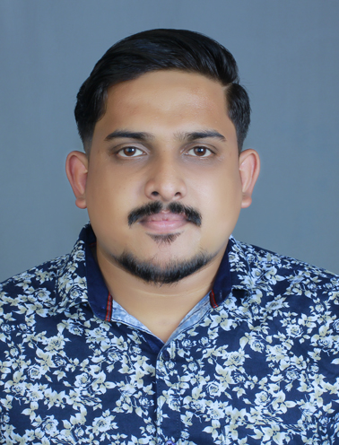
C/o-Mob : +971501685421
Mail: shihab.376809@2freemail.com

PROFILE HEADLINE:

Passionate Mechanical Engineer with 3yearsGCC Experience having technical knowledge in order to implementing process and performing evaluations to ensure compliance with technical specifications and to effectively complete the projects duly on time

CAREER OBJECTIVE:

Persuasion of a challenging career and be part of a progressive organization that gives scope to enhance knowledge, skills and reach the pinnacle in this field with sheer determination, dedication and hard work.

Professional Experience
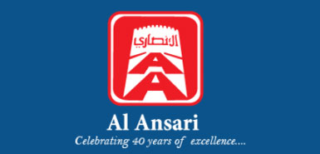
AL ANSARI TRADING ENTERPRISE LLC, MUSCAT,OMAN – 3 YEARS

Designation: Project & Procurement Engineer

Project Handled (2015-2017):

- BRITISH PETROLEUM PDO site- Khazzan
- GERMAN EMBASSY-Oman
- ROYAL OMAN POLICE PROJECT -15 locations
- CITY HOTEL , Muscat
- CROWN PLAZA- OCEC,
- MARRIOT HOTEL– Muscat
- COVE ROTANA–RAK
- DAMAC PROJECT- Qatar
- ROYAL OMAN POLICE PROJECT - 9 locations
- SHERATON HOTEL Oman
- IBIS HOTEL-Sohar

Areas of Expertise

- Post order processing activities.
- Design review, Heating&cooling load calculation, copper pipe sizing for VRF system.
- Pipe routing, pump head calculation, duct sizing and airflow routing, placing of machines review and correcting.
- Prepare detailed engineering drawings with all necessary sections, ducting, piping etc.
- Provide effective planning/scheduling functions on projects in accordance with clients/company policies, procedures, specifications and project baseline.
- Preparation of HVAC drawings and submission to clients for approval.
- Drawing and feasibility of installation of Duct, AHU units.
- Implementing of safety norms.
- Studying the bar chart, monitoring progress of work and its updates.
- Final measurement entry and passing bills.
- Procurement schedule preparation.
- Communication skill and negotiation in with the European and American suppliers

COMPUTER QUALIFICATIONS & EXPERIENCES:

- Programming in C and C++
- Auto CAD

- CATIA V5
- ANSYS 15
- Microsoft excel
- Microsoft power print

EDUCATION:

- ST. GITS COLLEGE OF ENGINEERING (M.G. UNIVERSITY).
B-Tech (Bachelor’s Degree) in Mechanical Engineering
Aggregate Percentage: 7/10

- ME 105-’ Product development for developing world’–
Caltech(USA) - Art center -SAINTGITSjoint research programme, June 2012 –April 2013.

- Advanced certificate course in HVAC from KELTRON knowledge center, Kottayam.

PROJECT WORK

Design of Multi-Utility wheelchair. (Final semester project for the fulfillment of requirement forthe bachelor’s degree in Mechanical Engineering)

- Designed and analyzed a multi-utility wheelchair

- Fabricated the wheelchair at a reasonable cost that is affordable for common people.

- It can be used as wheelchair and stretcher as well.

- Height of this can be adjusted to 80cm.

- Portable and durable.

- Best project in college.

Design of mechanical rubber mat punching machine. (Ajoint academic course ‘ProductDesign for developing world’ provided by CALTECH Institute ofTechnology, California).

- Best project in the course
- Fabricated rubber mat punching machine that would help workers in mat industry to punch multiple holes in mat with ease and accuracy.
SEMINAR

- Removal of burr and pits using GFRP tool on small gears. (Final semester seminar for the fulfillment of requirement for the bachelor’s degree in mechanical Engineering

PROFILE:

- Team member of CALTECH - SAINTGITS - Art center (USA) joint Research programme, June 2012 –April 2013.
- Industrial trainings at Autokast, Cherthala and Travancore cements, Kottayam.

- Multi-utility wheelchair development (Best Project).

- Rubber mat punching machine design (Best Project).

ACHIEVEMENTS/KEY ROLES HELD:

- Winner for the best project (Rubber mat punching machine) at Caltech Institute of technology.

- Best final year project (multi- purpose wheelchair).
- Finalist at TECHTOP (National level technical project competition held at Mar Basalious College of Engineering),2014.

SKILLS AND KNOWLEDGE:

- Interested in machine modeling and analysis.

- Thorough understanding of engineering standards.

- Ability to work under pressure of work load/time constraint.

- Dependable friendly and hardworking.

- Enjoys meeting new challenges and seeing them through completion, while remaining confident and good humored under pressure.

- Quick to learn and skilled at working with people, analyzing their problems

PERSONAL PROFILE:

Nationality : Indian
Sex : Male

Date of Birth : 25/014/1991

Marital Status : Single

Languages Known : English, Malayalam, Hindi, and Arabic

Driving License (Sultanate of Oman) GCC

Driving license issued by : Royal Oman Police

Date of issue Date of expiry : 18/11/2025

