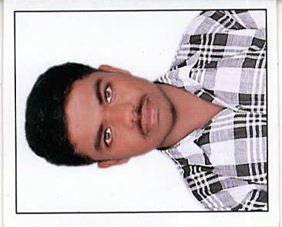
CURRICULAM VITAE
BINEESH
U A E, AL AIN
C/O Rowena - 0501685421
Email : bineesh.377529@2freemail.com

CARRIER OBJECTIVE
Highly resourceful individual with the ability to interact with people at all levels, and the goal of being an effective and reliable player in a world class organization where there is opportunity for growth and creativity. I would like to have an opportunity to contribute myself effectively for the growth of the organization.

CAREER SUMMARY
Experience as an CIVIL ENGINEER (2017 June to Now working)
(Sapphire swimming pools maintenance LLC,UAE,Dubai)
Pools Construction, maintenance, landscaping and all interior Works in UAE

Experience as an CIVIL ENGINEER (2015 November to 2017 April)
(Zorba Interior Décor Company LLC,UAE,Al Ain)
All Interior Works in UAE and UAE University Al Ain

Experience as an SENIOR ENGINEER (2013 March to 2015 October)
( Centre For Research And Development)
World Bank Jalanidhi Project in Balal GP under Jalanidhi Project)

Experience as an SITE ENGINEER (2011 April to 2013January)
( KPK GROUP DESIGNERS AND BUILDERS)
Various building construction Project sites in Kerala.)

DUTIES AND RESPONSIBILITIES:
- Day to day management of the construction sites, including supervising and monitoring the labour force and the role of subcontractors.

- Overseeing quality control and health & safety matters at site.

- Liaising with any consultant, sub-contractors, supervisors, planners, quantity surveyors and the general work force involved in a project.
- Site visit and Preparation of BOQ and drawing submittals.
- Preparation of checking of Working Drawings, Shop Drawings and BOQs.
INTEREST
Knowing World’s most amazing designed structures.

EDUCATIONAL QUALIFICATION
- DIPLOMA IN CIVIL ENGINEERING 65% - 2010
Department of Technical Education
Kerala
- HIGHER SECONDARY EDUCATION 59% - 2007
Directorate of Higher Secondary Education
Kerala
- SSLC 76% - 2005
Board of Public Examination
Kerala
COMPUTER SKILLS
- CERTIFICATION COURSE
AutoCAD 2006
- Microsoft Excel, Microsoft Word
PERSONAL STRENGTH
- Ability to work independently and under pressure.
- Quick learner and Continues Improvement.
- Good communication skill.

- Leadership.

- Team work and Self Confidence

- Valid Driving License in UAE

- Registered member in Society of Engineers UAE.(2017/47749)

- Pass the examination in Dubai Municipality, Qualified on Landscaping works.{ITST-2017-003840)

PERSONAL INFORMATION
Age & Date of Birth : 27& 08TH JAN 1990
Nationality : Indian
Gender & status : Male &Single
Religion : Hindu,Maniyani
Languages : English, Malayalam, Hindi, And Tamil

PASSPORT DETAILS
Date of Issue : 14/12/2010
Date of Expiry : 13/12/2020
Visa status : Residences

DRIVING LISCENCE DETAILS

Date of Issue : 28/09/2017
Date of Expiry : 27/09/2019

DECLARATION
I hereby certify that all the information stated above are true and complete, to the best of my knowledge and belief
Dubai BINEESH

