CURRICULUM VITAE

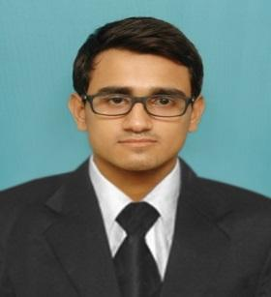
ADARSH
Phone: (M) C/o 971501685421
E-mail: adarsh.377685@2freemail.com

CAREER OBJECTIVE:
Devoting my potentials sincerely towards my work, learning the competitive advantage in the emerging scenario of hotel industries thus gradually reaching to an esteemed position of my goal.

AREA OF INTEREST: Sales and Customer Service.

WORK EXPERIENCE:
- Customer service at shopping mall
- Two years at call centre
- Currently employed at Grand Barbeque Restaurant in service.

ACADEMIC PROFILE:

COURSE | UNIVERSITY/  BOARD | COLLEGE/SCHOOL | YEAR | %
Higher Secondary | NIOS | B.D. Memorial Academy | 2011 | 50.2%
Secondary | NIOS | B.D. Memorial Academy | 2009 | 64%

LANGUAGE KN0WLEDGE:

LANGUAGES | READ | WRITE | SPEAK
English | Fluently | Fluently | Fluently
Hindi | Fluently | Fluently | Fluently

PERSONAL PROFILE:

Date of birth: 22/11/1993
Nationality: Indian
Sex: Male
Hobbies: Music, playing sports, Photography, Reading, Driving.

Issue Date | 28/06/2017
Expiry Date | 27/06/2027
Passport Details :

STRENGTH PERCEIVED:
- Good Presence of mind
- Passionate
- Consistent Performer
- Strong Determination
- Self Confidence

.

Declaration
I hereby declare that all the information furnished above is true to the best of my knowledge and belief.
Place: Sharjah – UAE

Date: 17/02/2018

ADARSH

