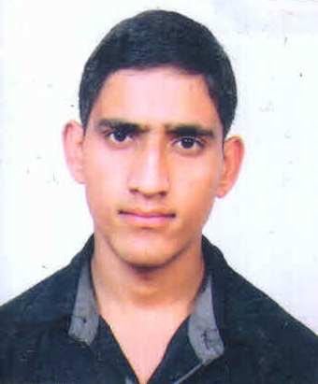
CURRICLUM VAITE

ANKU
Mob. No: C/o 971503718643
E-Mail : anku.377810@2freemail.com
OBJECTIVE
Seeking a responsible position in which I will best utilize my skills and abilities and offer avenues for professional growth Besed on my capabilities and hard work.

EDUCATIONAL QUALIFICATION

- 10th Passed from H.P Board in 2010-11
- 12th Passed from H.P Board in 2012-13

PROFESIONAL QUALIFICATION

- Diploma in Hotel Management from Aryan Group of Mandi (H.P)

EXPERIENCE

- VT from Taragarh Place Hotel (A Welcome Heritage Hotel) w.e.f. 06/05/2014 to 15/07/2014
- IT from Hotel Howard Plaza Fatehabad Road Agra w.e.f 27/10/2014 to 01/05/2015
- JT from Hotel Four Point By Sheraton Agra (A Starwood Hotel ) w.e.f 15/02/2016 to 14/08/2016
- Worked In Hotel Four Points By Sheraton Agra (A Starwood Hotel) w.e.f 16/08/2016 to 20/07/2017 as a Commi III

AREA OF INTEREST

- F&B Production

STRENGTH

- Leadership
- Ability to Adapt
- Good Communication

HOBBIES

- My work is my hobby

PERSONAL DETAILS

Name : Anku
Date of Birth : 25/07/1996
Marital Status : Unmarried
Gender : Male
Nationality : Indian
Languages Known : Hindi, English
Passport Issue date : 27-07-2015
Passport Expire date : 26-07-2025

DECLARATION:-
I hereby declare that information formation furnished above is true to be best of my knowledge

Date.....
Place...... (ANKU)

