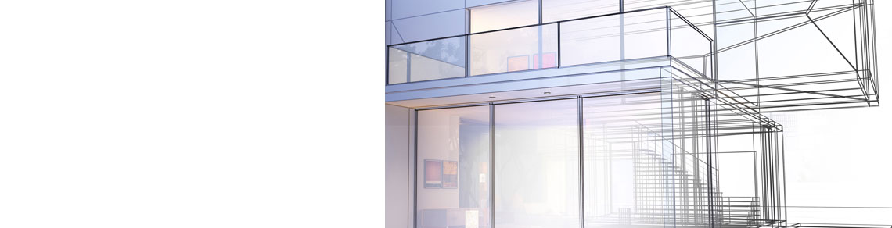
Revit Modeler/ Draughtsman
ANSHAD Email: anshad.377838@2freemail.com Ph: C/o 971501685421

Location : Dubai, UAE
Education : Diploma in Civil Engineering
Experience : 2 Year and 9 months
Passport Date of Issue: 20/02/2015 Date of Expiry: 19/02/2025
Managerial Skills
- Involved in projects from evaluation, conception and completion
- Excellent interpersonal , collaboration, and problem solving skills combined with excellent written and verbal communication skill
- Strong understanding of software to develop drawings and supervise drawing team
- Quick learner and team player
Technical Skills
Modeling Tools: Autodesk Revit, Autodesk 3D s Max, Sketchup.
Drafting: AutoCAD 2016
Structural Design: STAAD Pro V8i, eTabs 2016
Surveying Drawing: LISCAD
EXPERIENCES
April 2017 To January 2018 |  | Company : Derive Design and Build Solutions, India  Position : BIM Modeler
Duties: Modeling and drawing preparation in Autodesk Revit, Structural drafting and detailing, modeling and design of structure in STAAD and eTabs
Main Projects Involved:
- Robotic car parking unit in India
- Cantilever Space truss for convention Centre
- Steel container building in Oman
- Metro Staging in Vyttila
July 2016 To March 2017 |  | Company : Associated Constructions, India  Position : CAD Engineer
 |  | Duties: Modeling of building using Revit architecture, preparing working drawings of various commercial and residential building. Rendering views as per client requirement.
July 2015 To June 2016 |  | Company : Associated Constructions, India  Position : Jr. CAD Draftsman  Duties: Preparing architectural drawings of various commercial and residential building, documentation.
EDUCATION
Diploma in Civil Engineering 2015
Board of Technical Education, Kerala
LANGUAGES KNOWN
 | Beginner | Intermediate | Expert
English
Arabic
Arabic
Hindi
Tamil
Malayalam

