SHAKIR  C/o-Mobile No. +971501685421  Email: shakir.377956@2freemail.com | 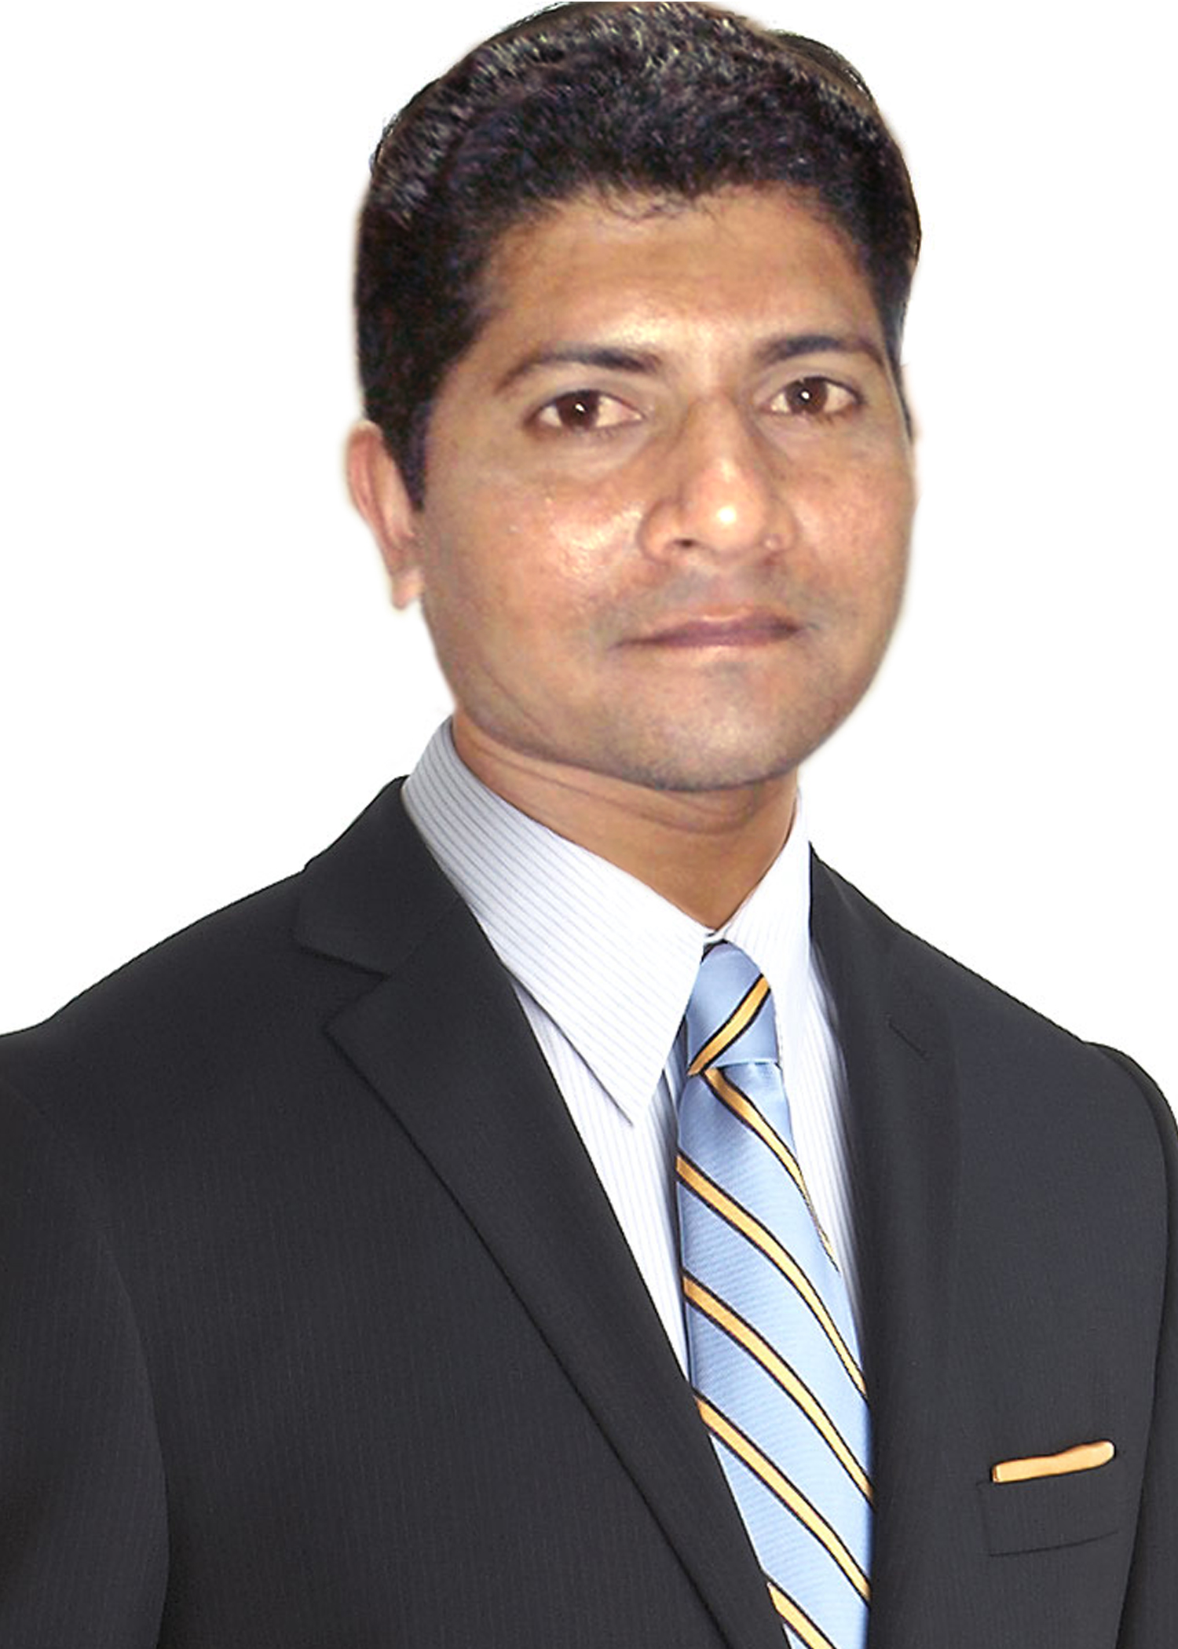

OBJECTIVE:
To join an organization which has competitive motivation and enthusiastic environment to enhance my potentials and get valuable learning.

PROFESSIONAL QUALIFICATION:

- 03 Years of Diploma Associate Engineering in Biomedical Technology in ( 2008).

ACADEMIC QUALIFICATION:

- Matriculation from Karachi Sindh Board in( 2000).

INTERNSHIP EXPERIENCE:

- Months Worked as a Trainee in Biomedical Department Civil Hospital Karachi.

JOB DESCRIPTION:

- Installation, Service and Maintenance of the Bio Medical Equipments.

Critical Care Equipments:

Cardiac Monitor.
Patient Monitors.
E.C.G Machines.
C.T.G Machines.
Fetal Monitors.
Infusion and syringe Pumps.
Baby Warmer.
Baby Incubators.
Suction Machines.
Air Purifier (IQ Airr).
Electric Patient Bed.
O-T Lights.
Electric Operation Tables.
Oxygen Concentrators.

EXPERIENCE:

- (Jan 2008 To 2011 Dec )Worked as Senior Bio Medical Technician, STANDARD SUPPLIERS, Karachi, PAKISTAN.
- (Jan 2012 To 2013 Dec) years and 6 months worked as a Bio Medical Technician in Farasan General Hospital Under the Ministry of Health, FARSAN, (KSA).
- (Jan 2014 To 2015 March) Worked as Bio Medical Technician in MIDHNEB General Hospital Under the Ministry of Health, AL-QASSIM, (KSA).
- Care Health Solutions (2015 August till continue......)

EXPERTIES:

Provide technical /clinical service on CTG System, Huntleigh/ UK.
Provide technical service on Cardiac Monitors of Space lab,Gold way and Schiller.
Provide technical service on Incubator-Ohameda,Nigbo David.
Provide technical service on Infant and Adult ventilators of Respironics USA.
Provide technical service on Suction Machines of MGE,UK.

COMPUTER SKILL:
- Having command in environment of Windows XP,7 & 8, Microsoft Office.

OTHER SKILLS:
- Good communication and interpersonal skills.
- Ability to work and interact with teams and groups.

INTEREST:
Playing Cricket.
Surfing and Browsing
Reading Newspapers

PERSONAL INFORMATION:

Date of Birth : June, 07, 1980
Marital Status : Married
Religion : Islam
Nationality : Pakistani

References: Excellent references will be furnished upon request.

