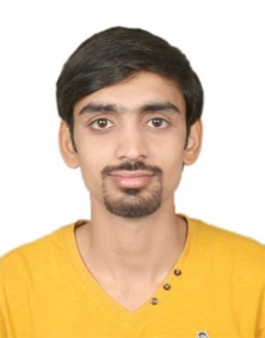
Sandeep

C/o-Contact Details:
+971 504973598
sandeepmakwana93@gmail.com

SYNOPSIS

- A self-confident, motivated, energetic, dynamic Professional.
- Ability to work in a dynamic environment and under pressure situations.
- Possess honesty and the ability to work hard with determination and dedication.

OBJECTIVE

To establish myself at an esteemed height in the field of Accountancy by putting in my best for the organization I will be associated with. I intend to work with well-experiencedprofessionals so that I can excel in my skills to give my best in the growth of the organization.

ACADEMIA

Degree | Year | Board/University | Institution
B.Com | 2014 | Mumbai University, India | Thakur College
H.S.C | 2011 | Maharashtra State Board, India | Lords Universal College
S.S.C | 2008 | Maharashtra State Board, India | Sanskar English High School

WORK EXPERIENCES

Organization: Assistant Manager- New Dimension,Teenagers Embroidery&Janvi Art, India
Period: June 2014 till Date
Role:
- At present, looking after the overall accounting work.
- Looking after the overall Taxation matters including direct tax and indirecttax.
- Collection of receivables, financial planning, factory management and expansion etc.
- Payments of raw materials purchased such as embroidery threads, bobbin’s thread, paper canvas, kasabjari, sequences,etc.
- Slashed payroll/benefits administration costs 30% by negotiating pricing and fees, while ensuring the continuation and enhancements of services.
- Monitoring and adjusting price as required.
- Maintaining inventory levels of raw materials and machinery spare parts.
- Ensure proper paperwork flow and invoicing of the finished products.
- Confirming the timely payment of statutory dues.
- Filing of GST (Goods and Service Tax).
- Overall responsibility of providing accurate and timely information to the Management.

EXTRAMURAL ENGAGEMENTS

- Diploma In Basic Electronics and Computer Hardware (2009)
- Familiar with Window XP/7/Vista/8/10
- Familiar withMicrosoft Word, Microsoft Excel, Internet and other basic skills of computer.

PERSONAL DOSSIER

- Date of Birth | :26th January, 1993
- Languages Known | :English, Hindi, Gujarati and Marathi
- Marital Status | :Married
- Visa Status | : Visit (Till April)
DECLARATION

I hereby declare that the above mentioned information is true to the best of my knowledge.

