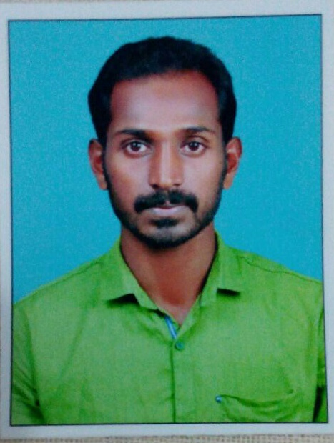
CURRICULUM VITAE

BIBIN
UAE Mob: C/o 971501685421
E-Mail: bibin.378051@2freemail.com

Aiming positions as SITE ENGINEER with a leading organization for my career growth

AN OVERVIEW
- A Civil Engineer having over TWO and HALF YEAR of experience in site engineering for civil related to general Building construction.

ENTREPRENEURIAL VENTURES
Lee builders, architect engineer's and contractors. Period of 1st may 2015 to 31st dec2017.

Key Deliverables:
- Carry out site inspection and leveling of site.
- Carry out the measurements for billing on site.
- Carry out inspection for materials delivered to site.
- Carry out inspection of steel during concrete.
- Checking plans, drawings and specifications.
- Overseeing the selection and requisition of materials.
- Supervising and monitoring the site labour force and the work of subcontractors.
- Overseeing the quality control and health and safety measures of the staffs.
- Preparing and submitting reports.

ACADEMIC CREDENTIALS
- 2011- 2015 BE (Civil) from Satyam College of Engineering and Technology, Aralvoimozhi, Anna University Chennai.

IT SKILLS
- Proficient in MS OFFICE, SURFING INTERNET.
- AUTOCAD .

DOSSIER
- Date of Birth : 25/05/1994
- Gender : Male
- Nationality : Indian
- Marital status : Unmarried
- Mother Tongue : Malayalam
- Linguistic Abilities : English, Tamil, Malayalam and Hindi.

DECLARATION
I hereby declare that the above mentioned data is true to the best of my knowledge and belief.

Bibin

