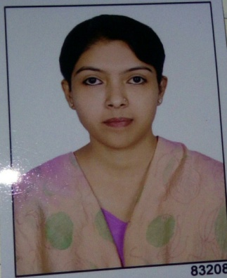
APPLICATION RESUME

SOLANKI
C/o-CONTACT NO: +971502360357
E-MAIL: solanki.378082@2freemail.com
CAREER OBJECTIVE
To work for the organization to the best of my knowledge and ability from where the organization could benefit from my service and provide me with quality work experience.
ACADEMIC CREDENTIALS
- I have passed my S.S.C Examination with 54%.
- I have passed my H.S.C Examination with 69.27%.
- I have passed my B.COM Examination with 52% with second class.
- I have passed my I.T.I SOFTWARE PROGRAMMING course of 1 year with 59%.
- I have passed my TALLY 9.0(F.A.S) course first class.

EXPERIENCE:
I have 2 years experience as clerk and office administration work.
Veritasimmigration and education pvt. ltd.
EXPECTED SALARY
As per your rules.

INTERPERSONAL SKILLS
- Ability to build up relationship and set up trust.
- Ability to cope up with different situations.
- Willingness to learn and work with great patience.

PERSONAL DETAILS

- Date Of Birth: 13 FEBRUARY 1988
- Address:23/ Ganpat society, Shahibaug,ahmedabad-4.
- Gujarat,India.
- Nationality: Indian
- Hobbies: Reading, Listening to soft music.
DECLARATION

- I hereby declare that the above information provided is true to the best of my knowledge.
Hoping for a positive response from you.

Solanki

