CURRICULUM VITAE  PRASAD  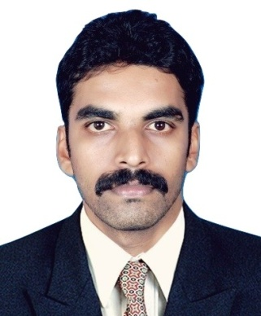  CONTACT  prasad.378086@2freemail.com  C/o-UAE : +971-501685421  OBJECTIVE  To work with a reputed organization which can provide me with a wide range of Opportunities to expand my skills and work with them to provide a healthy and safe work culture. I want to gain more experience benefitting both the company and myself  SoftwareSKILLS  - AutoCad 2012  - Solid edge  - MS office  FINAL YEAR PROJECT (B.TECH)  Improved Design and Development of  Butterfly Valve Body Casting,  Autocast Ltd, Cherthala  Details: Designed and developed a  gating and risering system for the  components of a butterfly valve , studied  and analyzed various steps in casting.  Personal Skills  - Young, enthusiastic, hardworking  - Good learner and good listener  - Keen observer of events  - Willingness to upgrade skills & knowledge  - Ability to work in any  Environment  - Co-Operative with people to learn more  - Interested in learning new  topics  PERSONAL DETAILS  father’s name r.s krishna swamy  date of birth 19-11-1990  sex male  marital status single  nationality indian  PASSPORT DETAILS  DATE OF ISSUE 22/08/2012  DATE OF EXPIRE 22/08/2022  VISA DETAILS  VISIT VISA 3 Months  VALID TILL 16 May 2018 | EDUCATIONAL QUALIFICATION’S  2010-2014 BTECH MECHANICAL ENGINEERING  2015-2016 DIPLOMA IN INDUSTRIAL SAFETY  2008-2010 HIGHER SECONDARY EDUCATION  CERTIFICATION  - NEBOSH IGC in Occupational Safety and health (result waiting)  - IOSH Managing Safely  - CIEH level 2  - Basic first aid  EXPERIENCE  SAFETY OFFICER, EMK Construction's  Kollam, Kerala  Key Responsibilities:  • Inspects the site to ensure it is a hazard-free environment.  • Conducts toolbox meetings  • Is part of the project safety council and leads all efforts to enhance safety  • Verifies that injury logs and reports are completed and submitted to related government agencies  • Verifies that all tools and equipment are adequate and safe for use.  • Promotes safe practices at the job site.  • Enforces safety guidelines.  • Trains and carries out drills and exercises on how to manage emergency situations.  • Conducts investigations of all accidents and near-misses.  • Conducts job hazard analyses.  • Establishes safety standards and policies as needed.  • Performs emergency response drills.  • Watches out for the safety of all workers and works to protect them from entering hazardous situations.  •Responds to employees’ safety concerns.  •Coordinates registration and removal of hazardous waste.  SAFETY OFFICER, RIL PCG J3 PROJECT JAMNAGAR (UNDER L&T LTD)  Jamnagar, Gujrat  Key Responsibilities :  •Inspects the site to ensure it is a hazard-free environment  •Promotes safe practices at the job site.  •Ensure that a building or product complies with health and safety regulations, especially after an inspection that required changes  •Review employee safety programs and recommend improvement’s  •Anticipate, identify and evaluate hazardous conditions and practices.  •Implement, administer and advice others on hazard control programs.  •Conduct job safety Analysis.  •Coordinates registration and removal of hazardous waste  •Responds to employees’ safety concerns  CO-CURRICULLAR ACTIVITIES  - Participated in Inter college Badminton Tournament  - Participated in inter college Cricket Tournament  - Lab Expo In charge For REVELZ 2013  - Event Coordinator at CEEMECS 2012  - Part Of Sponsorship Committee CEEMECS 2012  - Conducted various cultural events at school level  - Member of Help Age India  DECLARATION  I hereby declare that the above written particulars are true and correct to the best of my knowledge and belief.  Date Place PRASAD

