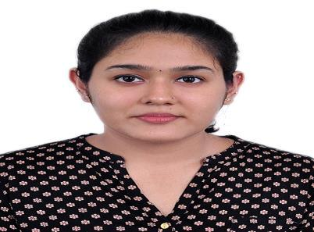
Aishwarya
Dubai, UAE

C/o 971501685421
Aishwarya.378094@2freemail.com

Capable of working independently and committed to providing high quality service to every project, with focus on health, safety and environmental issues. Professional, capable, and motivated individual who consistently performs in challenging environments. Also possess Master’s degree in Structural Engineering.

OBJECTIVE

Seeking a challenging position which will enable me to continuously learn, Create, Innovate and simultaneously contribute to the short term and long-term goals of the organization.

PROFESSIONAL EXPERIENCE

Mass Associates Chennai, India | November 2016 to July 2017
Structural Engineer Trainee
- Estimating material, construction, and labour costs, and project timescales.
- Involved in producing due diligence surveys. Liaising with local contractors.
- Load assessments of new and existing structures.
- Communicating with government agencies and local authorities.
- Evaluating, organizing & prioritizing work within the overall project schedule.
- Preparing sketches, marking-up drawings and writing specifications etc.

- Liaising with architects, engineering technicians and IT staff. Structural inspections/assessments and making appropriate recommendations.
- Providing expert technical advice including structural reports, crack monitoring.

EDUCATION

M. Tech (Structural Engineering), SRM UNIVERSITY CGPA 9.662

Chennai, Tamil Nadu, India | 2014 to 2016

B. TECH (Civil Engineering), SRM UNIVERSITY CGPA 8.953

Chennai, Tamil Nadu, India | 2010 to 2014

CLASS 12th, URSULINE SR. SECONDARY SCHOOL CBSE, Percentage 71%

Kannur, Kerala | 2010

CLASS 10th, URSULINE SR. SECONDARY SCHOOL, CBSE, Percentage 85.2%

Kannur, Kerala | 2008

PROJECTS & INTERNSHIPS

POST GRADUATION PROJECT:

Title: Behavior of Reinforced Short Concrete Column under Axial Loading

Funded by: Department of Science and Technology (DST)

Description: The primary objective was to study the application of copper slag as an alternative replacement material of sand. The behavior of copper slag concrete column under axial loading was studied. The increase in load bearing capacity of copper slag concrete column compared to the normal concrete column was found out.

POST GRADUATION INTERNSHIP:

- Underwent an In-Plant training at PWD Building Sub Division, Kannur, Kerala from 25/05/2015 to 18/06/2015. The training focused on Foundation Engineering and SPT

GRADUATION PROJECT:

Title: Adsorption of CHROMIUM (VI) using crab shell

Description: The ability of crab shell to remove chromium from tannery waste water was investigated and the properties of tannery waste water were studied. Wasted biomaterial was used as an adsorbent in chromium removal.

GRADUATION INTERNSHIP:

- Underwent an In-Plant training at L&T construction, Chennai from 02/06/2012 to 18/06/2012. The training focused on Green building concept

- Underwent an In-Plant training at Moopan builders, Kerala from 23/05/2013 to 07/07/2013. The training focused on Design of concrete structures

AREA OF INTREST

- Structural Engineering
- Construction Management
- Planning

PERSONAL DETAILS

Fathers Name

Date of birth
Sex
Passport No
Marital Status

Proficiency in languages

: Jaya

: 25/04/1992
: Female
:
: Single
: English, Malayalam, Tamil & Hindi

Visa Status

: UAE visiting visa valid until 15th April 2018

Yours Sincerely,

(Aishwarya)

