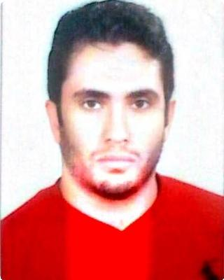

WORK

EXPERIENCE

ABDELRAHMAN

E-mail: abdelrahman.378095@2freemail.com
Phone: C/o 971503718643
Dubai, United Arab Emirates

Mr.Fit Club Jan 2010 — Aug 2012

Personal Trainer

Assisted 80 customers per month, with track record of helping 70% of clients reach goal within first month
Designed personalized programs and nutritional plan for clients for optimal results Provided exceptional customer service, securing 40% of new clients through referrals

Checked all gym equipment for proper use and functions, minimizing accidents or malfunctions
Received “Best Personal Trainer” Award in 2011

Intercontinental Hotel, Port Ghalib, Aug 2012 — Sep 2013
Marsa Alaam

Fitness Trainer

Taught fitness class based on Body Combat to over 30 students per class

Instructed clients on proper equipment use as well as exercises to be done at home

Exceeded revenue targets by 20% within 3 months

Kempinski Soma Bay Jan 2014 — Jul 2014

Fitness Trainer

Guide clients in safe exercise, taking into account individualized physical limitations.
Devise and announce new classes and distribute guest passes to market the club. Consistently attain facility targets, including revenue goals and member retention rates.
Lead clients and occasional groups of all ages through personal workouts and skill development training.
Administer fitness assessments, which include the seven point skin-fold body fat measurements, blood pressure, and treadmill tests. Counsel clients on proper nutrition and exercise habits.

Baazim Body Building Oct 2014 — May 2017

Fitness Trainer

Assisted in the operation of a clean, friendly, and well maintained health club. Recorded training sessions and maintained package rates for each client. Helped older adults with weight training by setting up equipment and providing instructions.

Encouraged clients to engage in group fitness classes and other activities in the gym to meet fitness goals and improve overall well being and health. Contributed to a 30% increase in sales for the personal training department.
Provided exceptional customer service to members and guests throughout the club.

Assisted with additional club responsibilities as needed.

Designed injury rehabilitation programs.

Ensured safe and effective use of equipment.

ABDELRAHMAN 1

Siva Marsa Allam Aug 2017 — Present

Gym Trainer

Specialized in one to one personal training, with older adults and post-rehab clients.
Measured overall fitness by completing comprehensive evaluations and assessments.
Designed innovative and customized training programs based on fitness goals. Worked with clients to improve their overall endurance, strength, flexibility and balance.
Educated clients about the relationship between nutrition and fitness.

QUALIFICATIONS Training of Kung Fu Trainers

Training of Cross Fit

Training of Emergency First Response

Training course in Hospitality.

Training of International lives saving federation Egyptian diving & lifesaving fed.

Weider academy of cultural training ( National Coach ).

TRAINING Power walking

SKILLS Boxing course

Cross fit

Steeper exercise

Taybo exercise

Stretching and yoga

Rehabilitation of injuries

Water gymnastics

Teaching swimming

Make Bodybuilding system

Make system of healthy food

Spilling exercise

Teaching fighting Kung Fu Sanda

EDUCATION Faculty of Technology 2005 — 2007

El Mahalla El Kubra

INTERESTS Football, Swimming and Reading

ABDELRAHMAN 2

